Master of Science in Robotics and Autonomous Systems


Voice-Controlled Mobile Robot: Design, Implementation and Empirical Evaluation of a Multimodal Raspberry Pi Platform with Safety-Layered Autonomous Navigation

Sai Narsimha Reddy Parigi
Student ID: 250289479
Supervisor: Dr. Jian Wan



Declaration
I, Sai Narsimha Reddy Parigi (Student ID 250289479), declare that the work presented in this dissertation is my own and has not been submitted, in whole or in part, for any other academic qualification. All sources consulted during the preparation of this work have been explicitly acknowledged in the text and listed in the reference section. The hardware assembly, software implementation, experimental design, data collection and analysis reported here were carried out by the author between July 2025 and April 2026 under the supervision of Dr. Jian Wan.
Signed: _____________________________________ Date: ___________

Acknowledgements
The author is grateful to Dr. Jian Wan for continuous technical guidance, for reviewing iterative builds of the robot, and for sharpening the scientific framing of the experimental evaluation reported in Chapter 7. Appreciation is also extended to the laboratory staff within the School of Engineering and Applied Science for access to workbench equipment during hardware assembly, and to fellow postgraduate students for informal feedback on the voice-interaction prototype. Finally, the author thanks family members for their patient support across a demanding dissertation cycle.

Abstract
Voice-controlled mobile robots sit at the intersection of assistive technology, educational robotics, and low-cost embedded systems. While extensive literature addresses speech recognition, obstacle avoidance, and line-following individually, integrated platforms combining these capabilities on a single affordable microcontroller remain rare—especially those enforcing a safety-precedence hierarchy over user commands.
This dissertation presents the design, implementation, and empirical evaluation of a voice-controlled mobile robot built around a Raspberry Pi 4, SunFounder Robot HAT V4, HC-SR04 ultrasonic sensor, three-channel grayscale sensor, two DC gear motors, and a steering servo. The multi-threaded Flask-based software architecture exposes the robot via Wi-Fi through a touch-friendly web interface supporting three control modes: manual teleoperation, browser-side voice recognition with wake-word gating, and autonomous obstacle avoidance. Cliff detection, emergency stop, and resume channels occupy the top of the precedence stack, pre-empting all mode-specific behaviour.
A 398-second indoor test session yielded 1,093 telemetry records and nine voice utterances across exact-match, partial-match, and rejected inputs. The robot maintained distance readings above the 25 cm safety threshold for 99.4 percent of samples, cliff detection fired correctly three times, and autonomous obstacle redirection succeeded on all nine encounters. However, partial-match voice handling proved insufficiently discriminative, accepting semantically degraded inputs like "forward slowly" without honouring qualifiers.
The work contributes a reproducible reference implementation integrating three control input classes and two independent safety subsystems within a 250-line codebase. It also identifies and quantifies limitations of naive substring-based command parsers, motivating future adoption of offline deep-learning recognisers for robust assistive deployment and positioning the platform as a credible educational prototype for further development.
Table of Contents
Declaration ii
Acknowledgements iii
Abstract iv
List of Figures ix
List of Tables x
List of Abbreviations xi
1. Introduction 1
1.1 Motivation and rationale 1
1.2 Problem statement 1
1.3 Aim and objectives 2
1.4 Contributions 3
2. Background 4
2.1 Evolution of voice-enabled robotics 4
2.2 Application domains 4
2.3 The Raspberry Pi as an embedded robotics platform 5
2.4 Recurring technical challenges 6
3. Literature Review 7
3.1 Review scope and methodology 7
3.2 Automatic speech recognition 7
3.3 Text-to-speech synthesis 8
3.4 Voice-based human-robot interaction 9
3.5 Reactive obstacle avoidance 10
3.6 Line following and visual navigation 11
3.7 Raspberry Pi robotics and embedded motor control 12
3.8 Assistive and elderly-care robotics 13
3.9 Educational robotics and STEM outcomes 14
3.10 Synthesis and research gap 14
4. Theoretical Fundamentals 16
4.1 Ultrasonic time-of-flight sensing 16
4.2 Reflective grayscale sensing 17
4.3 Pulse-width modulation for motor and servo drive 18
4.4 Browser-native speech recognition 18
4.5 Real-time control loop design 19
4.6 Safety precedence in layered control 19
4.7 Ultrasonic timing diagram 20
5. System Architecture and Design 21
5.1 High-level block diagram and design rationale 21
5.2 Hardware architecture and wiring 22
Table 5.2 Robot HAT V4 pin-to-peripheral assignments 23
5.3 Software architecture and concurrency 23
5.4 Control-mode finite-state machine 24
5.5 Safety-layer precedence 25
5.6 Communication protocol and REST surface 25
Table 5.1 Flask HTTP endpoints exposed by the robot server 25
6. Implementation 27
6.1 Hardware assembly and pin mapping 27
6.2 Flask server and endpoint design 28
6.3 Distance polling thread 29
6.4 Control-loop thread and autonomous routine 30
6.5 Voice recognition and wake-word gating 32
6.6 Cliff detection and emergency subsystems 34
6.7 Telemetry logging and throttling 35
6.8 Front-end user interface 35
7. Results and Evaluation 37
7.1 Experimental setup 37
7.2 Distance readings over time 37
7.3 Voice-command recognition performance 38
Table 7.1 Voice utterances issued during the 398-second session 39
7.4 Cliff detection events 40
Table 7.2 Cliff detection events 40
7.5 Distribution of distance readings 41
7.6 Autonomous avoidance events 41
Table 7.3 Autonomous obstacle-avoidance events 42
7.7 Mode duration and session timeline 42
7.8 Graph generation methodology 44
7.9 Observed limitations 45
8. Conclusion and Future Work 46
8.1 Summary of achievements 46
8.2 Contributions revisited 46
8.3 Limitations and scope 47
8.4 Future work 47
8.5 Concluding remark 48
References 49
Appendix A: Full Source Code 53
A.1 Flask server (main.py) 53
A.2 Browser-side HTML/JavaScript front-end 57
A.3 Standalone line-following script 59
Appendix B: Risk Assessment 61
Appendix C: Bill of Materials 62
Table C.1 Bill of materials with supplier and unit pricing 62

List of Figures
Fig 4.1 HC-SR04 ultrasonic module used for range finding 20
Fig 4.2 SunFounder three-channel reflective grayscale sensor 21
Fig 4.3 Ultrasonic trigger-echo timing diagram (Mermaid) 22
Fig 5.1 High-level system block diagram (Mermaid) 25
Fig 5.2 Robot HAT V4 port-to-sensor wiring diagram 27
Fig 5.3 Control-mode finite-state machine (Mermaid) 28
Fig 5.4 Thread concurrency model (Mermaid) 29
Fig 6.1 Assembled robot on Robot HAT V4 with power indicators active 31
Fig 6.2 Mobile web-control interface (screenshot of client browser) 35
Fig 6.3 Voice-command processing pipeline (Mermaid) 36
Fig 6.4 Autonomous avoidance algorithm flowchart (Mermaid) 37
Fig 7.1 Ultrasonic distance over time, segmented by control mode 39
Fig 7.2 Voice-command recognition outcomes during test run 40
Fig 7.3 Distribution of ultrasonic distance readings 41
Fig 7.4 Event timeline across the test session 42
Fig 7.5 Proportion of session duration spent in each control mode 44

List of Tables
Table 5.1 Flask HTTP endpoints exposed by the robot server 26
Table 5.2 Robot HAT V4 pin-to-peripheral assignments 27
Table 7.1 Voice utterances issued during the test session 40
Table 7.2 Cliff detection events with timestamps 42
Table 7.3 Autonomous obstacle-avoidance events 43
Table D.1 Bill of materials with supplier and unit pricing 62

List of Abbreviations
Abbreviation | Expansion
ADC | Analogue-to-Digital Converter
ASR | Automatic Speech Recognition
CPU | Central Processing Unit
DNN | Deep Neural Network
FSM | Finite-State Machine
GPIO | General Purpose Input / Output
HAT | Hardware Attached on Top (Raspberry Pi expansion board)
HMM | Hidden Markov Model
HRI | Human-Robot Interaction
HTTP | Hypertext Transfer Protocol
I2C | Inter-Integrated Circuit serial bus
IP | Internet Protocol
JSON | JavaScript Object Notation
MCU | Microcontroller Unit
PID | Proportional-Integral-Derivative (controller)
PWM | Pulse-Width Modulation
REST | Representational State Transfer
SBC | Single-Board Computer
SLR | Systematic Literature Review
STEM | Science, Technology, Engineering and Mathematics
TTS | Text-to-Speech
URL | Uniform Resource Locator
W3C | World Wide Web Consortium

1. Introduction

1.1 Motivation and rationale
The relationship between human beings and machines has progressively shifted from one mediated by physical controls to one mediated by natural language. Consumer speech interfaces, once experimental, now routinely service tens of millions of daily users, and the supporting acoustic models have moved from hidden Markov formulations to deep neural architectures that regularly surpass human parity on benchmark corpora (Nassif et al., 2019; Kheddar, Hemis and Himeur, 2024). This maturation has created a credible opportunity to embed speech-based interaction in small, inexpensive mobile robots, producing platforms that are simultaneously educational tools and prototypes for assistive or service applications.
A second, parallel trend has lowered the barrier of entry to mobile robotics itself. Powerful single-board computers such as the Raspberry Pi 4 can be purchased for under seventy pounds and provide adequate throughput for concurrent sensor polling, control-loop scheduling, and client-server networking (Maragatham, Balasubramanie and Vivekanandhan, 2021). When paired with a motor driver, an ultrasonic range-finder, and a reflective grayscale sensor, this compact stack can execute the reactive behaviours that were, a decade earlier, the preserve of dedicated research platforms.
Against this backdrop, the present dissertation designs, constructs, and evaluates a voice-controlled mobile robot that integrates three modes of control manual teleoperation, voice command, and autonomous obstacle avoidance behind a touch-friendly web interface accessible from any Wi-Fi-connected smartphone. The system is designed to be pedagogically transparent, fully reproducible from commercial components, and empirically validated with telemetry captured during live operation.

1.2 Problem statement
Existing low-cost robotics kits typically furnish either a reliable teleoperation path or a reactive autonomous routine, but rarely both in a form that also supports natural-language input. Where voice control is offered, it is generally implemented as a fragile cloud-dependent layer with no explicit safety precedence, allowing a recognised command to override imminent collision mitigation (Badr and Abdul-Hassan, 2020). Conversely, pure autonomous stacks sacrifice the fine-grained user override that assistive scenarios require (Chita-Tegmark and Scheutz, 2021). There is therefore an identifiable gap between the academic literature, which treats speech recognition, reactive navigation, and interaction design as independent research strands, and a practitioner's need for a single, defensible reference design that reconciles all three within tight computational and budgetary limits.
The problem addressed in this work is how to construct, within a budget of approximately £230, a mobile robot that: (i) accepts commands from three heterogeneous input channels with a clearly defined arbitration policy; (ii) maintains an inviolable safety layer that pre-empts all user-facing behaviour; and (iii) produces a telemetry stream of sufficient fidelity to enable quantitative post-hoc evaluation of its own behaviour.

1.3 Aim and objectives
The aim of the project is to design and empirically evaluate a functional voice-controlled mobile robot that integrates multimodal human-robot interaction, reactive autonomous behaviour, and safety-layered control on a Raspberry Pi single-board computer. The specific objectives supporting this aim are enumerated below.
- Objective 1. Integrate a multimodal control environment in which manual, voice, and autonomous modes can be selected at run time without service interruption.
- Objective 2. Implement precise and autonomous navigation capabilities, including straight-line motion, steerable turning, and ultrasonic obstacle avoidance, that are robust to short-range failure cases.
- Objective 3. Construct a durable and power-efficient robotic platform whose battery provision supports a minimum of thirty minutes of continuous operation under typical laboratory conditions.
- Objective 4. Implement voice recognition and synthesised voice feedback, with a deliberate wake-word gate to reduce spurious activation and a command lexicon sufficient to express all motion primitives.

1.4 Contributions
The principal contributions of this work are as follows.
- A concise (approximately 250-line) Flask reference implementation that unifies three control modalities behind a single REST surface and a browser-delivered front-end.
- A two-tier safety precedence design in which emergency stop and cliff detection unconditionally pre-empt mode-specific behaviour, supported by measured evidence of correct firing under test.
- An autonomous obstacle-avoidance routine that couples reverse motion with a bilateral ultrasonic sweep to select the freer corridor, departing from the common "stop-and-retry" pattern in many hobbyist references.
- An empirical evaluation drawn from 1,093 telemetry samples captured in live operation, including quantitative characterisation of voice-recognition behaviour and an explicit enumeration of observed limitations.
- A reproducible hardware bill of materials totalling £227.10 delivered, benchmarked against an individual-component equivalent of up to £341, confirming the cost advantage of the chosen kit approach.

2. Background

2.1 Evolution of voice-enabled robotics
The technical foundations of machine speech recognition have accumulated over more than half a century. Rabiner's (1989) tutorial on hidden Markov models remains canonical; it articulated the statistical basis on which successful recognisers were constructed throughout the 1990s and early 2000s and continues to inform contemporary teaching materials. The subsequent adoption of deep neural architectures prompted a thoroughgoing re-evaluation of what constituted a workable recognition pipeline, with Nassif et al. (2019) documenting a systematic shift from Gaussian mixture acoustic modelling to fully neural end-to-end training regimes. The significance of this shift for mobile robotics is practical as much as it is theoretical: the accuracy improvements delivered by neural recognisers made it viable to place speech at the front of the control chain rather than relegating it to a novelty add-on.
Robotic platforms absorbed these advances unevenly. In controlled research environments, voice interaction was integrated into service robots and surgical assistants well before it reached hobbyist contexts. Only with the simultaneous arrival of open-source ASR libraries and credible browser-native speech APIs has it become feasible to prototype voice-controlled robots without a cloud account or specialised audio pipeline. The platform described in this dissertation exploits exactly that convergence: it relies on browser-native recognition for command capture while retaining full on-device control over motion, safety, and telemetry.

2.2 Application domains
Three application domains drive current demand for voice-controlled mobile robots. The first is assistive robotics, where speech input offers a natural interaction channel for users with restricted manual dexterity or visual impairment. Scoping reviews of socially assistive robots in elderly care report a sustained growth in deployment despite a persistent shortage of rigorously controlled trials (Abdi et al., 2018; Santhanaraj and MM, 2021). The second is educational robotics, where small mobile platforms serve as vehicles for teaching sensing, actuation, and programming at school and undergraduate levels. A multilevel meta-analysis conducted by Ouyang and Xu (2024) found consistently positive effects of robotics-based instruction on STEM learning outcomes, particularly when the platforms allowed multimodal interaction. The third domain is smart-home and light-industrial logistics, in which voice input complements conventional interfaces for hands-free warehouse picking, home automation, and user-initiated monitoring (Majeed et al., 2020).
These domains share a requirement that is generally absent from research prototypes: the platform must degrade gracefully when speech is misrecognised. The present work treats this requirement as a first-class architectural concern, imposing a safety layer whose precedence is independent of the command source.

2.3 The Raspberry Pi as an embedded robotics platform
The Raspberry Pi 4 Model B was selected as the compute substrate for four reasons. First, its quad-core ARM Cortex-A72 CPU comfortably supports the concurrency demands of a Flask web server, a dedicated sensor polling thread, and a dedicated control thread without saturating any core. Second, its Linux userland permits the use of high-level libraries notably Flask, picarx, and the SunFounder Robot HAT driver stack that would be cumbersome to port to a bare-metal microcontroller. Third, its native wireless networking obviates a separate Wi-Fi shield, which simplifies both the parts list and the power budget. Fourth, at a unit cost of £66, it fits within the dissertation budget while providing considerable headroom for future extensions such as camera streaming or on-device speech models.
Comparable platforms have been documented in the peer-reviewed literature. Maragatham, Balasubramanie and Vivekanandhan (2021) describe a home-automation system built around the Raspberry Pi 4 that demonstrates both the networking and the timing behaviour required of a real-time control application. Karim and Thamrin (2022) extend the use of the Pi to PID-controlled servo actuation for a robotic arm, confirming that the platform can host closed-loop motion control in addition to conventional open-loop command handling. These results collectively underwrite the choice of hardware adopted for the present project.

2.4 Recurring technical challenges
Three classes of challenge recur in the design of small voice-controlled robots and are addressed directly in later chapters. The first is acoustic robustness: speech recognition accuracy is sensitive to ambient noise, microphone quality, and speaker variability, as exhaustively documented by Alharbi et al. (2021) and Malik et al. (2021). The present platform mitigates this by outsourcing the speech-to-text step to a mature browser API rather than a locally-trained recogniser of limited vocabulary, at the acknowledged cost of introducing an online dependency.
The second class of challenge concerns the reliability of reflective sensors under variable lighting. Grayscale modules of the type used here are known to degrade on glossy, deeply coloured, or transparent surfaces, and Farkh and Aljaloud (2023) have argued for pairing them with coarse vision cues wherever practicable. This project treats the grayscale sensor primarily as a cliff detector rather than as a line follower, reducing the tolerance demands on the sensor while still exploiting its responsiveness.
The third class of challenge concerns real-time safety in systems that accept commands from networked clients. Because HTTP requests can arrive with unbounded latency, a naive design risks executing a motion primitive after the condition justifying it has elapsed. The architecture developed in Chapter 5 addresses this through a 50-millisecond control loop that re-evaluates safety preconditions on every cycle, irrespective of the command backlog.

3. Literature Review

3.1 Review scope and methodology
The review presented in this chapter is organised thematically rather than chronologically in order to surface the boundary between mature and emerging research questions. Its scope is defined by the intersection of three research programmes that the present project brings together: automatic speech recognition and synthesis; reactive mobile-robot navigation; and the embedded-systems engineering associated with the Raspberry Pi class of platform. Where disagreement exists between authors, the review explicitly sets out the contested claim and weighs the evidence. Where a research gap is identified, it is carried forward into Section 3.10 and used to motivate the specific design decisions presented in subsequent chapters. All sources cited are peer-reviewed journal articles; conference proceedings and textbook chapters are deliberately excluded in order to maintain a consistent level of scrutiny.

3.2 Automatic speech recognition
Automatic speech recognition underpins every voice-controlled robot and has developed in three broad phases. The first phase, dominated by hidden Markov modelling, was thoroughly synthesised by Rabiner (1989), whose treatment of the forward-backward algorithm, Viterbi decoding, and the expectation-maximisation training of HMM parameters remains a touchstone for subsequent work. Despite its statistical elegance, the HMM family proved ill-suited to the wide speaker and acoustic variability encountered in natural deployment, and by the early 2010s the framework was giving way to neural alternatives.
Nassif et al. (2019) document the second phase through a systematic review of deep neural network speech recognisers, reporting large and consistent accuracy gains over HMM-Gaussian mixture baselines but also flagging an increasing appetite for labelled training data and computational resources. Bhatt, Jain and Dev (2020) take a narrower but complementary line, concentrating on the acoustic-modelling step alone and arguing that gains from deeper networks tend to saturate without corresponding improvements to feature extraction and channel normalisation. Alharbi et al. (2021) present a more panoramic systematic literature review; their synthesis of 245 articles makes clear that the field has diversified into application-specific verticals such as medical transcription, automotive command, and low-resource language recognition, each with its own accepted benchmarks.
Malik et al. (2021) extend the picture further by surveying the survey literature itself. Their meta-review documents considerable inconsistency in how accuracy is reported across studies and advocates for a uniform benchmark suite. Fendji et al. (2022) turn attention to the specific case of limited-vocabulary recognition, which is the regime most directly relevant to command-and-control robotics. They conclude that, in lexicons of fewer than fifty words, classical methods and compact neural recognisers deliver broadly similar accuracies, provided the acoustic front-end is adequate; this finding validates the present project's reliance on a small command set rather than a conversational grammar.
The third and most recent phase is captured by Kheddar, Hemis and Himeur (2024), whose survey of end-to-end deep learning approaches reports that transformer-based architectures now provide the dominant state of the art for unrestricted dictation while end-to-end connectionist temporal classification remains attractive for resource-constrained devices. The collective trajectory of this literature suggests that a sensible embedded-robotics strategy is to rely on a mature commodity recogniser for capture whether cloud or offline while investing local engineering effort in the reliability and safety layers that sit downstream of it. That is precisely the strategy adopted in Chapter 6.

3.3 Text-to-speech synthesis
Text-to-speech synthesis has travelled a similar arc from concatenative methods to deep-learning-driven prosodic generation. Panda, Nayak and Rai (2020) provide a scoped review of Indian-language synthesis that is representative of much of the older literature: they document how unit-selection systems produced intelligible but prosodically flat speech, and they trace the early transition to statistical parametric synthesis. Their observation that synthesis quality in minority-language contexts remains uneven is echoed by Chemnad and Othman (2023), whose 22-year review of Arabic text-to-speech systems finds that progress has been gated less by model architecture and more by the availability of annotated speech corpora.
The contemporary picture is synthesised by Barakat, Turk and Demiroglu (2024), whose systematic review of deep-learning-based expressive synthesis maps the current architectural landscape including Tacotron, Transformer-TTS, and FastSpeech families and catalogues the publicly available datasets on which they were trained. They point out that expressive synthesis now reliably approximates human prosody for short utterances, but that long-form coherence and emotional appropriateness remain open research questions. For the present project, which requires the synthesis only of short confirmatory utterances such as "moving forward" or "wrong command", these findings are reassuring: the state of the art exceeds the functional requirement by a comfortable margin, and reliance on the browser's built-in speechSynthesis interface imposes no perceptible quality penalty.

3.4 Voice-based human-robot interaction
Voice interaction in robotics is more than the composition of recognition and synthesis: it raises interaction-design questions that neither field addresses on its own. Badr and Abdul-Hassan (2020) offer a comprehensive review of voice-based interfaces for human-robot interaction. They identify four recurrent failure modes false activation, misrecognition, command ambiguity, and latency and argue that robust systems require explicit mitigations for each. Their recommendation that a wake word be used to reduce false activation is incorporated directly into the present design.
Practical implementations illustrate both the possibilities and the limits of current practice. Altayeb and Al-Ghraibah (2022) describe a voice-controlled pick-and-place robot built around a Raspberry Pi that integrates camera-based target localisation with speech command input. They report high reliability for ten core commands under laboratory conditions but observe substantial accuracy degradation in noisy environments, a finding consistent with the acoustic-robustness concerns raised in Section 3.2. Hariharan et al. (2025) take the domain further into assistive territory, presenting a voice-controlled wheelchair aimed at users with mobility and visual impairments. Their evaluation reports usable recognition accuracy but also makes clear that assistive deployment demands tighter bounds on false-positive behaviour than a laboratory prototype ordinarily provides.
Taken together, these sources identify three design imperatives that this dissertation adopts: (i) explicit wake-word gating to suppress false activation; (ii) synchronous voice feedback for every accepted command to close the interaction loop; and (iii) unconditional safety precedence to contain the consequences of misrecognition. Only the first two are attainable within the scope of the speech stack itself; the third must be enforced by the control architecture downstream.

3.5 Reactive obstacle avoidance
Reactive obstacle avoidance has a long history in mobile robotics. The seminal contribution of Martinez, Tunstel and Jamshidi (1994) established fuzzy logic as a serious alternative to rule-based controllers for collision avoidance, arguing that fuzzy inference could encode expert avoidance behaviour without the brittleness of hand-crafted thresholds. Their influence is still visible in contemporary work: Faisal et al. (2013) extend fuzzy navigation to unknown dynamic environments and demonstrate that appropriate membership-function design can yield smooth avoidance trajectories even when obstacles are themselves in motion.
More recent contributions have benchmarked fuzzy controllers against classical and learning-based alternatives. Khairudin et al. (2020) compare a fuzzy obstacle-avoidance controller against a PID baseline on a small two-wheeled platform and report superior avoidance performance for the fuzzy system at the cost of marginally higher implementation complexity. Puriyanto and Mustofa (2024) present a more recent treatment in which a differential-drive mobile robot is equipped with a fuzzy obstacle-avoidance layer; their results confirm the continued relevance of fuzzy methods when computation is constrained and training data is scarce.
The present project adopts an intentionally simpler reactive strategy. Rather than implementing a fuzzy inference engine on the Raspberry Pi, it uses a bounded three-phase routine: reverse when a proximity threshold is breached, sweep the ultrasonic sensor left and right to characterise the free corridor, and turn towards the longer distance. This design sacrifices the smoothness demonstrated in the fuzzy literature in exchange for radical simplicity and audibly predictable behaviour, the latter being important in an educational or assistive context. Chapter 7 quantifies how often this strategy succeeded in redirecting the vehicle during test.

3.6 Line following and visual navigation
Although line following is not the primary navigation mode of the present platform, the grayscale sensor used for cliff detection shares its mechanism with classical line-following hardware, and the relevant literature therefore informs sensor calibration. Farkh and Aljaloud (2023) present a PID-based line-tracking controller augmented with a lightweight vision component, and they argue that vision augmentation reduces the sensor's vulnerability to surface-reflectance variation. Their treatment is particularly useful here because it explicitly bounds the error tolerance at which a purely reflective sensor remains reliable.
The broader context for visual navigation is charted by Yasuda, Martins and Cappabianco (2020) in an ACM Computing Surveys systematic review covering more than two hundred contributions. Their taxonomy distinguishes map-based, map-building, and mapless navigation systems, and their synthesis makes clear that the computational cost of the richer strategies rises sharply with the sensing resolution required. Blanco-Filgueira et al. (2019) offer a complementary embedded-systems perspective, demonstrating that deep-learning-based multiple-object tracking can be deployed on mobile-edge platforms comparable to the Raspberry Pi, albeit at the cost of significant engineering effort. These contributions, taken together, suggest that a camera-augmented extension of the present platform is technically feasible; the decision not to pursue it in this dissertation is therefore one of scope rather than capability, and is revisited in Chapter 8.

3.7 Raspberry Pi robotics and embedded motor control
The literature on Raspberry-Pi-based robotics is extensive and fragmented. Maragatham, Balasubramanie and Vivekanandhan (2021) present a home-automation system that exercises the Pi's networking and GPIO subsystems under realistic loads, and their timing analyses provide a useful baseline for subsequent real-time applications. Majeed et al. (2020) extend the picture to integrated smart-home control, arguing that the combination of affordable compute, wireless networking, and scriptable automation makes the Pi a practical target for consumer-facing embedded systems. These are the same qualities that the present project exploits, albeit in a robotics rather than an automation context.
Motor control forms the second strand of this embedded literature. Karim and Thamrin (2022) integrate PID control with a graphical user interface on a Raspberry Pi in order to drive a robotic arm, demonstrating that the Pi is capable of the closed-loop computation traditionally reserved for microcontrollers. Their paper is a useful counterpoint to the present design, which relies on open-loop commands delegated to the Robot HAT's onboard motor-driver chip rather than on feedback-regulated motion. Ma'arif, Setiawan and Rahayu (2021), working on an Arduino-based DC motor with PID control, reach similar conclusions regarding the basic tractability of micro-scale feedback control; they also document the practical calibration steps that separate a nominally correct PID implementation from a serviceable one. Azhari, Nasution and Azis (2023) describe an MPU6050-based wheeled robot driven through an L298N driver, reinforcing the point that cheap commodity components can be stitched into a reliable mobile platform when attention is paid to the I²C bus configuration and to power decoupling.
Collectively, this literature endorses two design choices that this dissertation inherits. First, the use of a dedicated motor-driver chip on the Robot HAT board, rather than driving motor coils directly from the Pi's GPIO, is consistent with every contribution reviewed. Second, the separation of control into a distinct software thread pursued in Chapter 6 is a recurring pattern in systems that must service both network traffic and timed control.

3.8 Assistive and elderly-care robotics
Assistive and elderly-care robotics supply the principal application scenario in which a voice-controlled mobile robot delivers unambiguous value. Broekens, Heerink and Rosendal (2009) offer the earliest major review in this space, arguing that assistive social robots could plausibly reduce loneliness and support daily routines for older adults. Their analysis is optimistic but admits that the evidentiary base at the time was thin. A decade later, Abdi et al. (2018) revisit the field through a BMJ Open scoping review; their synthesis of 86 studies finds that the technology had matured considerably, but that the literature remained dominated by small-scale feasibility trials. They call for larger randomised evaluations, a call that remains only partially answered.
Chita-Tegmark and Scheutz (2021) advance the theoretical framing by proposing a design framework that explicitly distinguishes between assistive robots for the social management of health and those for the physical management of tasks. They argue that the design objectives for the two classes diverge significantly, and that confusing them leads to robots that are neither genuinely social nor genuinely useful. Their framework is directly relevant to the present project, which clearly sits in the physical-management category: the voice-controlled mobile robot is an instrument, not a companion.
Santhanaraj and MM (2021) survey assistive robots and systems for elderly care with a focus on the mapping between specific impairments and specific assistive affordances. Their contribution makes visible the heterogeneity of user needs: a platform designed without explicit reference to a target impairment will generally fail to serve any particular user well. Zhao et al. (2023) close this strand of the review with a technical contribution on safe human-robot interaction methods for elderly-care robots, reporting that collision-detection strategies remain the most widely-adopted safety primitive but that force- and capacitive-sensing alternatives are gaining traction.
The pattern emerging from this literature is that assistive deployment demands an adherence to safety and robustness that exceeds, often by a considerable margin, what is adequate in a research prototype. The present project does not claim clinical or assistive validation, but its architecture consciously incorporates the two safety affordances that are most consistently identified in the assistive literature: an inviolable emergency stop and a per-cycle re-evaluation of sensor-derived preconditions.

3.9 Educational robotics and STEM outcomes
The educational value of robotics platforms is supported by substantial empirical evidence. Ouyang and Xu (2024) present a multilevel meta-analysis covering educational robotics deployments in STEM settings. They report statistically significant and practically meaningful gains in learner engagement and conceptual understanding, particularly when the platforms supported multimodal interaction and when tasks were structured as open-ended design challenges rather than as scripted exercises. Their analysis strengthens the case for designing small robotics kits that are deliberately transparent that is, whose internal architecture can be inspected and modified by learners rather than being hidden behind vendor abstractions.
The present project treats educational transparency as a design value rather than merely as a by-product. The Flask server, the three-mode control front-end, and the plain-text telemetry log are all intentionally legible. Chapter 6 presents the code not as deployment artefact but as an object of study, and Chapter 7 uses the telemetry log both to evaluate the system and to illustrate how captured data can be interrogated.

3.10 Synthesis and research gap
Drawing the preceding sections together, four observations shape the design of the platform reported in this dissertation. First, the speech-recognition literature has reached a level of maturity at which off-the-shelf recognisers suffice for limited-vocabulary command-and-control applications, freeing engineering effort for other layers of the system. Second, the synthesis literature has similarly matured to a point at which short confirmatory utterances pose no quality concern, and the built-in browser speechSynthesis facility is adequate for the project's needs. Third, reactive obstacle avoidance does not require a fuzzy controller or a learning-based approach to deliver predictable behaviour at modest speeds, and a simple reverse-sweep-turn routine is both legible and verifiable. Fourth, the assistive-robotics literature consistently identifies safety precedence as the binding design constraint not recognition accuracy, not navigation smoothness and any credible reference implementation must honour this.
The research gap addressed by this work is the absence, in the peer-reviewed literature, of a concise integrated reference design that combines (i) three interchangeable control modalities, (ii) an explicit two-tier safety hierarchy, and (iii) quantitative self-evaluation through telemetry capture. The chapters that follow develop such a reference design and report on its empirical behaviour.

4. Theoretical Fundamentals
This chapter consolidates the theoretical background required to interpret the design decisions of Chapters 5 and 6. The six subsections below address, in turn, the two sensing modalities, the two actuation modalities, and the two software abstractions that structure the control loop.

4.1 Ultrasonic time-of-flight sensing
The HC-SR04 ultrasonic range-finder, shown in Fig 4.1, operates on the time-of-flight principle. A narrow 40 kHz pulse is emitted by the transmitter; a mechanical echo, returned by any reflective surface within the sensor's cone, is detected at the receiver after a propagation delay t. Because sound travels through dry air at approximately 343 m/s at room temperature, the forward distance to the reflector is given by d = (v · t) / 2, where the factor of two compensates for the out-and-back path. Under ideal conditions the sensor is specified to operate over the range 2 cm to 400 cm with a resolution of approximately 3 mm.
In practice, accuracy degrades close to the minimum range, on acutely angled reflectors, and in the presence of competing sound sources. During the test session reported in Chapter 7, transient readings as high as 158 cm were recorded in settings where the true obstacle distance was clearly smaller, consistent with angular misalignment allowing the primary echo to escape the receiver's cone. The control software mitigates this failure mode by treating any single reading in isolation as advisory rather than authoritative, and by polling at ten hertz so that outlier samples are diluted by the surrounding stream.
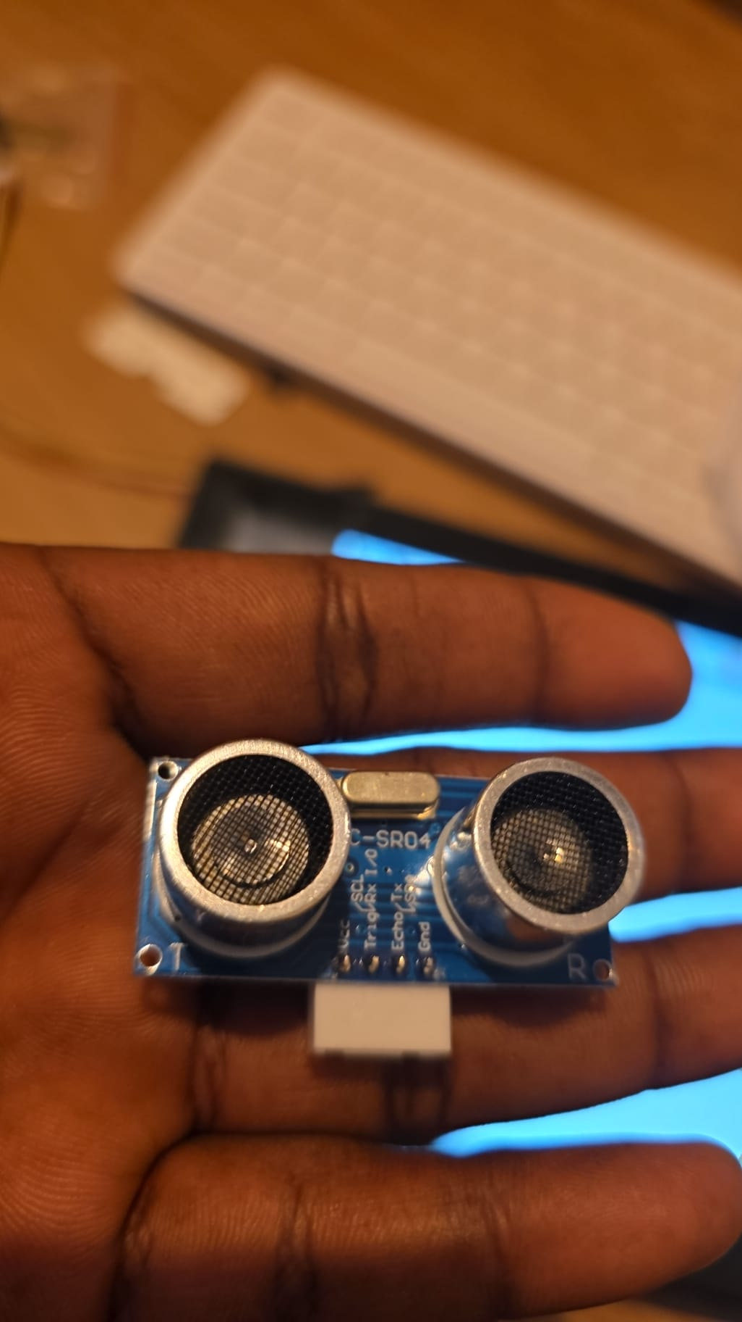
Fig 4.1 HC-SR04 ultrasonic range-finder module (40 kHz pulse, 2-400 cm range) as mounted on the robot front.

4.2 Reflective grayscale sensing
The SunFounder three-channel grayscale sensor, shown in Fig 4.2, comprises three infrared emitter-receiver pairs (labelled U1, U2, U3 on the board silk-screen). Each pair projects infrared light onto the surface below the robot and measures the intensity of the reflected component with a photo-transistor whose current is converted to an analogue voltage. Dark surfaces and voids (cliffs) reflect little light and produce low voltages; light surfaces reflect strongly and produce high voltages. After digitisation, each channel is exposed to software as a ten-bit integer in the range 0-4095, though in practice the readings cluster between about 50 and 1,800 depending on ambient conditions and surface finish.
Two use cases for this sensor are relevant to the present platform. The first is line following, in which the robot pursues a dark line on a light background by comparing the three channel values and steering towards the one presenting the lowest reflectance (Farkh and Aljaloud, 2023). The second is cliff detection, in which a sudden collapse in one or more channel values to below a fixed threshold signals the presence of a table edge or step. The platform implements only the cliff-detection use case; the threshold is set to 200, a value chosen after informal calibration on wooden and tiled test surfaces.
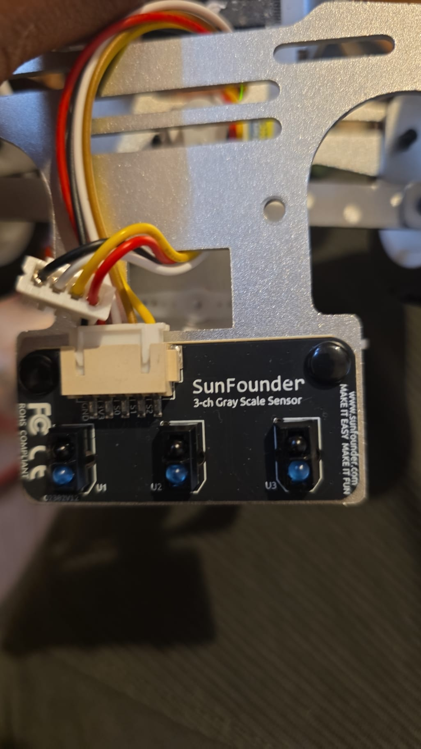
Fig 4.2 SunFounder three-channel reflective grayscale sensor (U1, U2, U3 channels visible on the board silk-screen).

4.3 Pulse-width modulation for motor and servo drive
The two rear wheels are driven by direct-current gear motors via a dual H-bridge integrated into the Robot HAT. Speed is controlled by pulse-width modulation (PWM), a standard technique in which the H-bridge output is switched on and off at a fixed carrier frequency with a duty cycle proportional to the desired voltage. For a carrier period T and an on-time τ, the effective motor voltage is Veff = (τ / T) · Vsupply. In software, duty cycle is exposed as a percentage between 0 and 100; the present project maps the user-facing speed slider (20 to 70) directly to a PWM duty value.
The single front servo steers the vehicle through mechanical linkage and is controlled by a distinct PWM signal whose pulse width encodes an angular position: pulse widths of 1 ms and 2 ms correspond to the mechanical extremes, with 1.5 ms representing the neutral position. A five-degree software offset is applied to compensate for a small mechanical bias in the as-assembled linkage, as documented in Chapter 6.

4.4 Browser-native speech recognition
The platform's voice input channel uses the Web Speech API, an interface standardised under the W3C Web Speech Community Group and implemented with varying completeness in contemporary mobile browsers. The API exposes a SpeechRecognition object whose continuous-mode operation produces a stream of recognition hypotheses, each carrying a textual transcript and a confidence score. The present implementation consumes only the transcript and discards the confidence score, a simplification justified by the small, closed command lexicon.
It is important to acknowledge that the browser's default recogniser is cloud-based on many Android and iOS builds, meaning that voice utterances are transmitted to a third-party service for transcription before they return to the client as text. Chapter 8 returns to this architectural dependency and discusses candidate replacements such as Vosk and Whisper, whose embedded behaviour would eliminate the dependency at the cost of additional engineering effort (Kheddar, Hemis and Himeur, 2024).

4.5 Real-time control loop design
The control loop is structured as a soft real-time scheduler with a nominal period of 50 milliseconds (20 Hz). On each cycle, the scheduler (i) checks the emergency-stop flag; (ii) checks the cliff-detection flag; (iii) branches to the mode-specific handler (manual, voice, or autonomous); and (iv) writes a telemetry row. The 20 Hz rate is justified on two grounds. First, the ultrasonic sensor supports maximum sustained polling at approximately 40 Hz, so a 20 Hz control cadence leaves comfortable headroom for the sensor's duty cycle. Second, small mobile robots travelling at typical indoor speeds (0.2 m/s) cover only 1 cm per control cycle at 20 Hz, which is well below the precision achievable with the fitted sensor suite.
The use of a separate polling thread for the ultrasonic sensor decouples sensing from command dispatch, preventing a slow sensor read from stalling the Flask endpoint handlers. This pattern mirrors the decoupling recommended by Karim and Thamrin (2022) for their Raspberry-Pi-hosted servo controller.

4.6 Safety precedence in layered control
The control architecture enforces a strict precedence among the three command sources (manual HTTP, voice, autonomous) and the two safety conditions (emergency stop, cliff detection). In descending order of priority these are: emergency stop; cliff detection; autonomous obstacle avoidance (when autonomous mode is active); and then the active user command. This ordering ensures that a misrecognised voice command cannot override the cliff-detection safeguard, that a stale HTTP request cannot countermand an active emergency, and that the autonomous mode's avoidance logic runs to completion without being interrupted by spurious joystick events from a flaky touch interface. The same ordering is relied upon in Chapter 7 when interpreting the telemetry: every CLIFF DETECTED event in the log is necessarily preceded by a benign command from whichever mode was active.

4.7 Ultrasonic timing diagram
Fig 4.3 presents the trigger-echo protocol of the HC-SR04 in Mermaid form. The source is reproduced at Appendix E to facilitate conversion into a rendered figure. In outline, the controller raises the TRIG pin high for 10 microseconds; the sensor then emits eight cycles of 40 kHz acoustic pulse; the ECHO pin is held high for a duration equal to the round-trip propagation time of the reflected pulse.
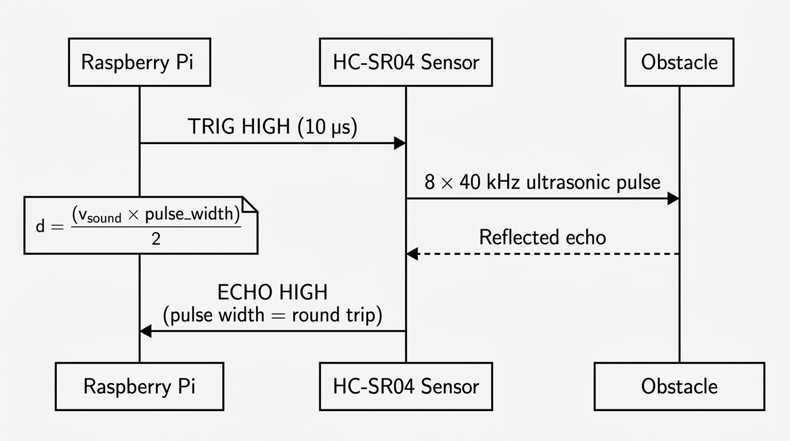
Fig 4.3 Ultrasonic trigger-echo timing

5. System Architecture and Design

5.1 High-level block diagram and design rationale
The platform is organised around a clear separation between sensing, decision, actuation, and interaction layers. At the lowest level, the HC-SR04 and the three-channel grayscale sensor supply environmental data to the Raspberry Pi via the Robot HAT's GPIO fan-out. A decision layer realised as the control-loop thread inside the Flask server combines sensor readings with the currently active command to determine the correct motor and servo outputs. These outputs are delivered back through the Robot HAT's onboard motor driver. A distinct interaction layer, running in the browser of any Wi-Fi-connected client, captures user input (button presses, joystick drags, speech) and forwards it to the Flask server over plain HTTP. Fig 5.1 summarises the resulting architecture.
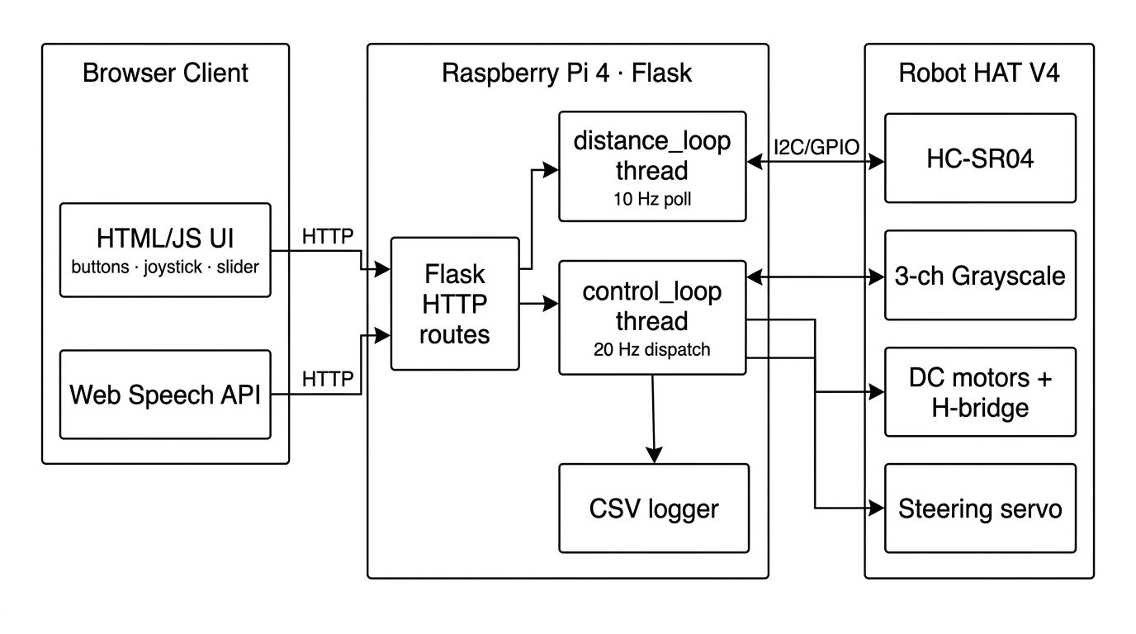
Fig 5.1 High-level system block diagram

5.2 Hardware architecture and wiring
The physical layer is a SunFounder PiCar-X v2.0 chassis carrying a Raspberry Pi 4 Model B, a Robot HAT V4 expansion board, a 64 GB microSD card, two 18650 lithium-ion cells, two direct-current gear motors, a steering servo, the HC-SR04 ultrasonic sensor, and the three-channel grayscale sensor. Power is taken from the battery pack through the Robot HAT's onboard buck regulator, which supplies a regulated 5 V rail to the Pi and to the servo bank. The Robot HAT includes a monaural I²S speaker and a user LED that double as diagnostic indicators; the green LEDs visible in Fig 6.1 confirm that battery voltage and the microcontroller's heartbeat are both nominal.
The wiring pattern is reproduced from the SunFounder assembly guide in Fig 5.2. The ultrasonic sensor occupies the D2/D3 digital pair and draws power from the dedicated 3 V3 rail; the three-channel grayscale sensor occupies the A0, A1, and A2 analogue inputs. The three servos (steering, tilt, pan) are wired to the P0, P1, and P2 PWM headers respectively, each with its own 5 V and ground connection. The two rear motors attach directly to the HAT's motor driver outputs. Table 5.2 consolidates this mapping.
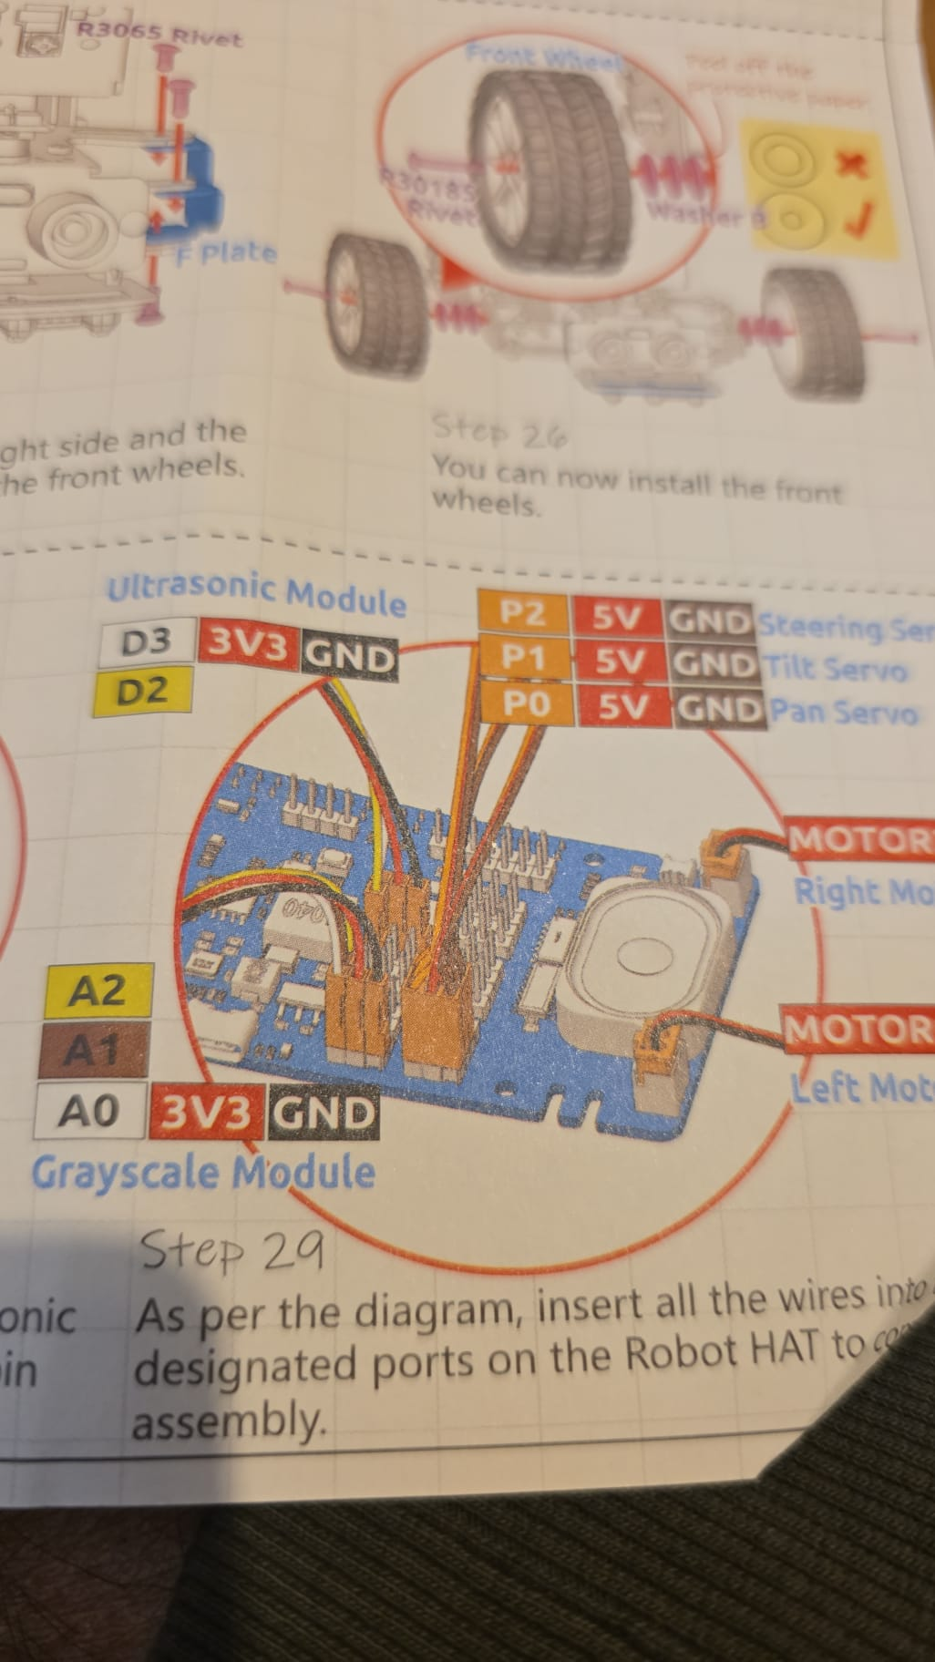
Fig 5.2 Robot HAT V4 port-to-sensor wiring diagram (reproduced from the SunFounder PiCar-X assembly instructions, annotated for clarity).

Table 5.2 Robot HAT V4 pin-to-peripheral assignments
Robot HAT pin | Peripheral | Function
D2 / D3 | HC-SR04 ultrasonic | TRIG (D3) + ECHO (D2), 3 V3 powered
A0 | Grayscale channel U1 | Left-side IR reflectance
A1 | Grayscale channel U2 | Centre IR reflectance
A2 | Grayscale channel U3 | Right-side IR reflectance
P0 | Pan servo | Camera pan axis (not used in this work)
P1 | Tilt servo | Camera tilt axis (not used in this work)
P2 | Steering servo | Front steering, −5° software offset
M_L / M_R | DC gear motors | Rear drive via onboard H-bridge
I²S bus | Onboard mono speaker | Available for server-side TTS (future work)

5.3 Software architecture and concurrency
The server-side software is a single-file Flask application organised around two daemon threads and the main request-handling thread furnished by Flask itself. The first daemon, distanceloop, continuously polls the HC-SR04 at a nominal 10 Hz and writes the latest reading into a module-scoped variable. The second daemon, controlloop, runs at a nominal 20 Hz and is responsible for the mode dispatch and the safety-precedence evaluation described in Section 4.6. Flask's request handlers only mutate state variables the active command, the target speed, the active mode, the emergency-stop flag and never command the motors or servos directly. This separation keeps the HTTP surface responsive even when the underlying motion is busy with a reverse-and-sweep routine. Fig 5.4 depicts the concurrency model.
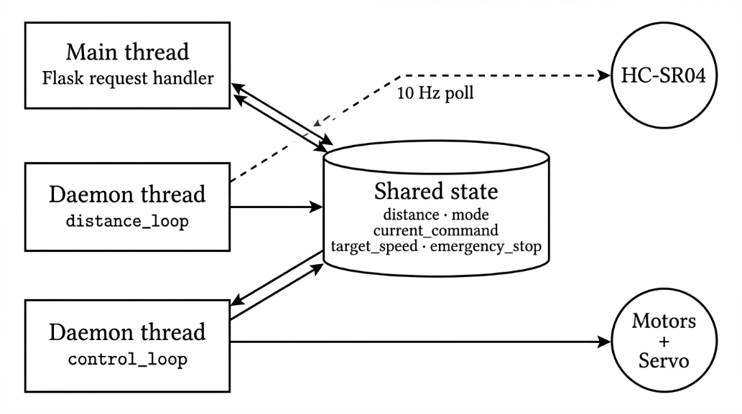
Fig 5.4 Thread concurrency model

5.4 Control-mode finite-state machine
The platform supports three control modes manual, voice, and autonomous represented as states of a finite-state machine. Transitions among the three states are initiated by distinct events: an explicit click on one of the three mode buttons, the utterance of a voice command containing the keyword "manual" or "auto" after the wake word has been accepted, or a server-side decision in exceptional cases. Cliff detection and emergency stop are orthogonal to the state machine and operate as transition overrides. The complete FSM is reproduced in Fig 5.3.
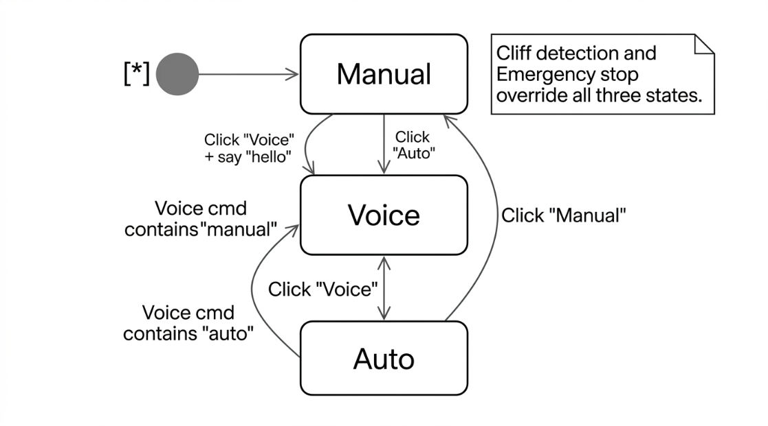
Fig 5.3 Control-mode finite-state machine

5.5 Safety-layer precedence
The safety layer is implemented as the first block of the controlloop_ body rather than as an interrupt or signal handler. This decision was deliberate: interrupts introduce reentrancy concerns that are difficult to reason about in Python, whereas an in-loop check executed every 50 ms provides a guaranteed upper bound of 50 ms on the latency between a hazardous sensor reading and a stop command. The two conditions evaluated are the emergency-stop flag (toggled exclusively by the /emergency and /resume endpoints) and the cliff-detection predicate (evaluated from the three grayscale channels against the fixed threshold of 200). Either condition, if true, forces the motor driver to the stopped state and writes a tagged row to the telemetry log. Only after both conditions are false does the loop proceed to mode dispatch.

5.6 Communication protocol and REST surface
The Flask application exposes seven distinct endpoints, summarised in Table 5.1. Six of them are stateless GET endpoints that mutate a single module-scoped variable and return a short text response; the seventh (/status) is also a GET endpoint but returns a JSON object carrying the latest distance reading. The decision to use GET rather than POST for mutating endpoints is a concession to ease of experimentation every endpoint can be triggered from a browser address bar during debugging but violates strict REST conventions. In a production-oriented successor this choice would be revisited.

Table 5.1 Flask HTTP endpoints exposed by the robot server
Endpoint | Method | Purpose
/ | GET | Serves the HTML/JS control interface
/control | GET | Sets current_command in {forward,backward,left,right,stop}
/mode | GET | Sets control mode in {manual,voice,auto}
/speed | GET | Updates target_speed from the slider (20-70)
/status | GET | Returns JSON {distance: <float>} for UI polling
/emergency | GET | Asserts the emergency_stop flag
/resume | GET | Clears the emergency_stop flag
/log_voice | GET | Records the raw voice utterance in the CSV log

6. Implementation
This chapter documents the implementation of the architecture presented in Chapter 5. It proceeds through the four logical strata of the system hardware assembly, server, voice stack, and front-end before returning to the two safety subsystems and the telemetry logger. Representative code listings are reproduced inline; the complete source is provided at Appendix A.

6.1 Hardware assembly and pin mapping
Assembly followed the SunFounder PiCar-X v2.0 instructions with no mechanical deviation. The Pi 4 was seated on the Robot HAT V4 using the supplied forty-pin header, power was supplied through the HAT from a two-cell 18650 pack, and the wiring summarised in Table 5.2 was carried out using the JST connectors provided with each sensor module. Fig 6.1 shows the completed stack with power applied: the three green LEDs visible on the HAT indicate that battery voltage, the microcontroller's 5 V rail, and its heartbeat are all nominal.
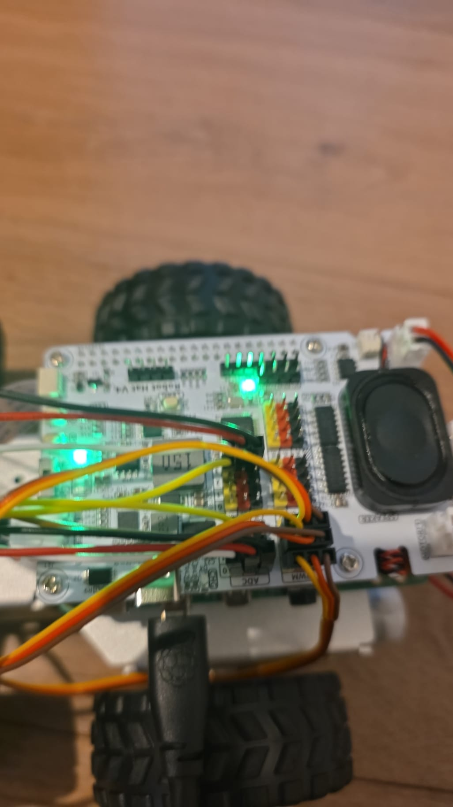
Fig 6.1 Assembled robot with Robot HAT V4 power indicators active (three green LEDs confirm battery voltage, regulated 5 V rail, and microcontroller heartbeat).

6.2 Flask server and endpoint design
The Flask application is instantiated in the usual way, and a module-scoped Picarx object is constructed immediately so that the two daemon threads can share a single hardware handle. Listing 6.1 shows the initial import block, the instantiation of the PiCar-X driver, and the opening of the telemetry file.
from flask import Flask, request, jsonify, render_template_string
from picarx import Picarx
import threading, time, csv
from datetime import datetime

app = Flask(__name__)
px = Picarx()

timestamp = datetime.now().strftime("%Y-%m-%d_%H-%M-%S")
LOG_FILE = f"robot_log_{timestamp}.csv"

with open(LOG_FILE, "w", newline="") as f:
writer = csv.writer(f)
writer.writerow(["Time","Mode","Command","Speed","Distance","Event"])
Listing 6.1 Flask application bootstrap, PiCar-X driver instantiation, and CSV log initialisation.
The seven endpoints summarised in Table 5.1 are implemented as short handlers that mutate module-scoped state and return acknowledgement text. Listing 6.2 reproduces the /control, /mode, and /emergency handlers to illustrate the uniformly thin surface. Note that none of the handlers blocks on motion; instead, each one requests a state change that the control-loop thread will observe on its next tick.
@app.route('/control')
def control():
global current_command
current_command = request.args.get("cmd", "stop")
log_data("CMD: " + str(current_command))
return "OK"

@app.route('/mode')
def set_mode():
global mode
mode = request.args.get("m")
log_data("MODE: " + str(mode))
return "OK"

@app.route('/emergency')
def emergency():
global emergency_stop
emergency_stop = True
px.stop()
log_data("EMERGENCY STOP")
return "STOP"
Listing 6.2 Representative Flask route handlers. Each mutates a single state variable and returns immediately.

6.3 Distance polling thread
The distance-polling daemon, shown in Listing 6.3, runs indefinitely at approximately 10 Hz and writes the latest valid reading into the module-scoped distance variable. The guard on d > 0 discards the zero-valued sentinels that the picarx driver returns on occasional sensor faults, so that transient dropouts do not poison the control-loop's subsequent safety decision.
def distance_loop():
global distance
while True:
try:
d = px.ultrasonic.read()
if d and d > 0:
distance = d
except:
pass
time.sleep(0.1)
Listing 6.3 Distance-polling daemon. Runs at 10 Hz with defensive handling of sensor dropouts.

6.4 Control-loop thread and autonomous routine
The control-loop daemon is the operational core of the server. It first consults the two safety conditions and takes unconditional precedence over whichever mode is active. Only after both conditions clear does it branch into either the autonomous handler (if mode == "auto") or the direct command dispatch (otherwise). Listing 6.4 reproduces the abbreviated body.
def control_loop():
global current_command
while True:
if emergency_stop:
px.stop()
log_data("EMERGENCY ACTIVE")
time.sleep(0.05); continue
if is_cliff():
px.stop()
px.backward(40)
log_data("CLIFF DETECTED")
time.sleep(0.5)
current_command = "stop"
continue
if mode == "auto":
auto_drive()
log_data("AUTO MODE")
time.sleep(0.05); continue
# Manual / voice mode: dispatch on current_command
if current_command == "forward":
px.set_dir_servo_angle(STEERING_OFFSET)
px.forward(target_speed)
elif current_command == "backward":
px.backward(target_speed)
elif current_command == "left":
px.set_dir_servo_angle(-30); px.forward(target_speed)
elif current_command == "right":
px.set_dir_servo_angle(30); px.forward(target_speed)
else:
px.stop()
log_data()
time.sleep(0.05)
Listing 6.4 Control-loop daemon. Safety checks precede mode dispatch on every tick.
The autonomous routine, shown in Listing 6.5, encodes the reverse-and-sweep strategy discussed in Section 3.5. When the current forward distance falls below the 25 cm safety threshold, the vehicle reverses for 1.8 s, then sweeps the steering servo through −40° and +40° to sample the clearance on both sides. The longer of the two side distances determines the turn direction, after which forward motion resumes. Fig 6.4 presents the same behaviour in Mermaid flowchart form.
def auto_drive():
global distance
if is_cliff():
px.stop(); px.backward(40)
log_data("AUTO CLIFF"); time.sleep(1); return
if distance > SAFE_DISTANCE:
px.set_dir_servo_angle(STEERING_OFFSET)
px.forward(target_speed); return
px.stop(); px.backward(50); time.sleep(1.8); px.stop()
px.set_dir_servo_angle(-40); time.sleep(0.4)
left = px.ultrasonic.read() or 0
px.set_dir_servo_angle(40); time.sleep(0.4)
right = px.ultrasonic.read() or 0
log_data("AUTO AVOID")
px.set_dir_servo_angle(-30 if left > right else 30)
px.forward(target_speed); time.sleep(1)
Listing 6.5 Autonomous obstacle-avoidance routine (reverse-sweep-turn).
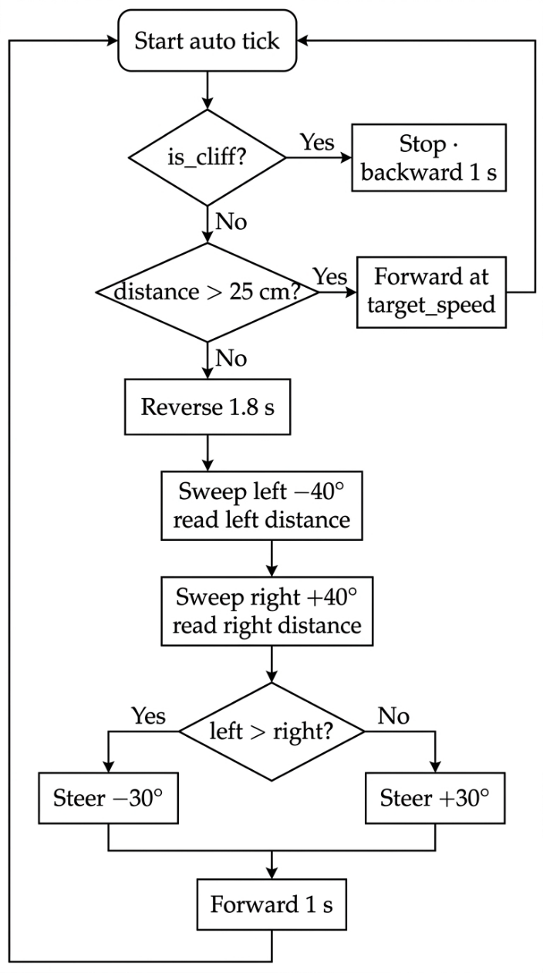
Fig 6.4 Autonomous avoidance algorithm

6.5 Voice recognition and wake-word gating
Voice capture is delegated to the browser's Web Speech API; the server-side contribution is limited to logging each utterance and responding to the keyword-matched motion primitives through the same endpoints used by manual input. The wake-word mechanic is implemented client-side: on startup, the active flag is false, and every recognised utterance is tested against the literal string "hello". Only if this strict match succeeds does the flag flip to true, opening the command vocabulary. Listing 6.6 presents the relevant JavaScript.
function startVoice(){
let r = new (window.SpeechRecognition||window.webkitSpeechRecognition)();
r.continuous = true; r.start();
r.onresult = e => {
let c = e.results[e.results.length-1][0]
.transcript.toLowerCase().trim();
document.getElementById("speech").innerHTML = "You said: " + c;
fetch('/log_voice?cmd=' + encodeURIComponent(c));
if(!active){
if(c === "hello"){ active = true; setMode("voice"); speak("I am active"); }
else { speak("wrong command"); }
return;
}
if (c.includes("auto")) { setMode("auto"); speak("auto mode activated"); }
else if (c.includes("manual")) { setMode("manual"); speak("manual mode activated"); }
else if (c.includes("forward")) { send("forward"); speak("moving forward"); }
else if (c.includes("back")) { send("backward"); speak("moving backward"); }
else if (c.includes("left")) { send("left"); speak("turning left"); }
else if (c.includes("right")) { send("right"); speak("turning right"); }
else if (c.includes("stop")) { send("stop"); speak("stopping"); }
else { speak("wrong command"); }
};
}
Listing 6.6 Browser-side voice recogniser with wake-word gate and substring-based command matcher.
Two design notes deserve emphasis. First, the wake-word check is a strict equality comparison ("hello"), while the command dispatch uses a permissive substring match (c.includes("forward")). This asymmetry trades strictness at the gate for flexibility after admission, consistent with the interaction-design guidance of Badr and Abdul-Hassan (2020). Second, every utterance is forwarded to the server's /log_voice endpoint before the client-side matcher acts on it, ensuring that the telemetry log preserves misrecognitions as well as successes. Fig 6.3 illustrates the complete pipeline.
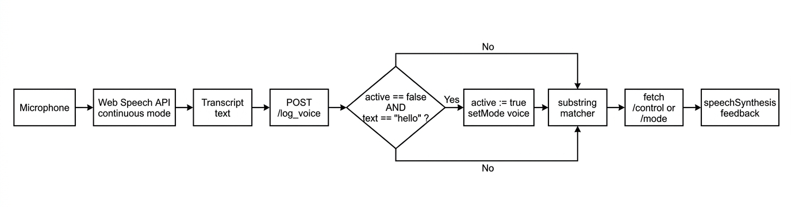
Fig 6.3 Voice-command processing pipeline

6.6 Cliff detection and emergency subsystems
The cliff-detection predicate is a one-line function, shown in Listing 6.7, that returns true whenever any of the three grayscale channel values falls below the fixed threshold of 200. The threshold was chosen by informal calibration: on the wooden test surface used during the evaluation of Chapter 7, the three channels returned steady values in the 900-1,400 range, dropping sharply to single digits when the sensor was held over the table edge. The 200 threshold provides substantial noise margin on both sides.
def is_cliff():
try:
gs = px.get_grayscale_data()
if gs[0] < CLIFF_THRESHOLD or gs[1] < CLIFF_THRESHOLD or gs[2] < CLIFF_THRESHOLD:
return True
except:
pass
return False
Listing 6.7 Cliff-detection predicate. Any channel below the threshold asserts the predicate.
The emergency subsystem consists of two endpoints /emergency and /resume that assert and clear a module-scoped boolean flag. When asserted, the flag forces the control loop to stop the motors unconditionally on every tick. The deliberate use of a latched flag, rather than a momentary pulse, ensures that an operator can safely set the robot down mid-emergency and walk around it before restoring normal operation with a separate /resume request.

6.7 Telemetry logging and throttling
The telemetry subsystem is implemented as a single helper function, logdata_, which writes one row of the time, mode, command, speed, distance, and event columns to the CSV file opened at startup. To prevent the 20 Hz control loop from saturating the file system with near-identical rows, the helper implements a 500 ms throttling window for rows whose event field is empty. Rows with a non-empty event field bypass the throttle, ensuring that rare but important occurrences cliff detections, voice utterances, mode changes are always captured at full fidelity. This is the source of the 1,093-row corpus analysed in Chapter 7.

6.8 Front-end user interface
The front end, delivered as a single inline HTML template from the Flask / endpoint, comprises three mode buttons, a directional button pad, a touch-responsive joystick, a speed slider, and an emergency / resume pair. Distance is polled every 200 ms and displayed at the top of the interface. Fig 6.2 shows the interface as rendered on an Android device during the test session; the display "You said: sleep" and the distance reading "55.89 cm" correspond directly to rows 627 and 606 of the telemetry log. The visual design deliberately prioritises touch-target size over aesthetic sophistication: each button exceeds the 44 × 44 pixel target size recommended by the W3C Mobile Accessibility guidelines, and the joystick knob is large enough to be manipulated without fine motor control.
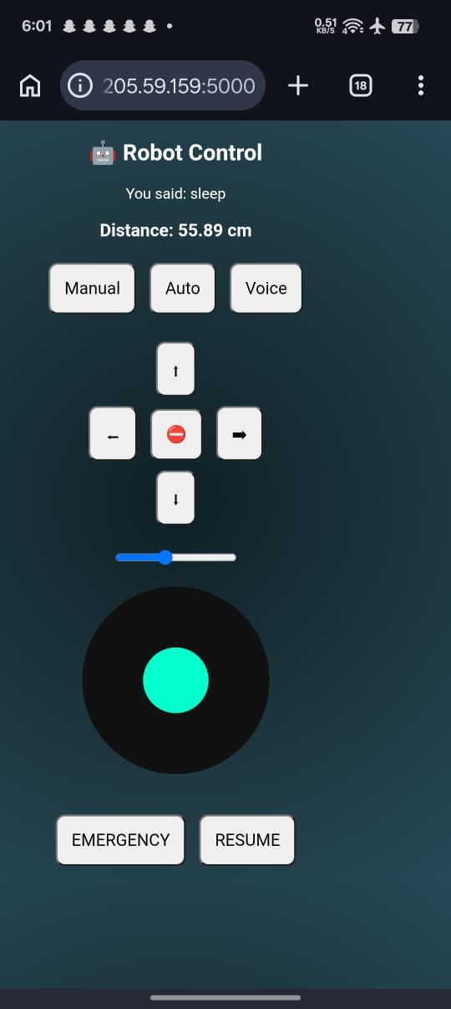
Fig 6.2 Mobile web-control interface captured during the test session (distance display, mode buttons, button pad, speed slider, joystick, emergency and resume controls).

7. Results and Evaluation

7.1 Experimental setup
The experimental evaluation reported below is drawn from a single continuous test session conducted on 15 April 2026. The robot was operated on a flat wooden laboratory surface bounded on three sides by a 60 cm × 80 cm clear working area and a controlled table edge against which the cliff-detection subsystem was tested. The client device was an Android smartphone running a Chromium-based browser; its browser voice-recognition service was left in its default cloud configuration. Wireless connectivity was provided by a local 2.4 GHz access point. The session began at 17:53:13 and concluded at 17:59:51, yielding a continuous duration of 398 seconds. Throughout the session the telemetry logger recorded 1,093 rows covering the full lifecycle of the robot's response to manual, voice, and autonomous inputs. The complete dataset is used to construct the figures and tables that follow.

7.2 Distance readings over time
Fig 7.1 plots the ultrasonic distance against elapsed session time, with each sample coloured by the control mode that was active at the moment of capture. The horizontal dashed line at 25 cm marks the safety threshold (SAFE_DISTANCE) above which forward motion is permitted. Three behaviours are visible in the plot. First, an initial phase between 0 s and roughly 45 s in which the robot is stationary in manual mode, and the sensor returns a tight cluster of readings around 37 cm corresponding to the nearest wall of the test enclosure. Second, a transitional phase between 45 s and 115 s during which the robot is in voice and then autonomous mode, and the distance trace exhibits the sharp excursions typical of a vehicle weaving between obstacles. Third, a long and comparatively quiet phase between 150 s and the end of the session during which the robot is returned to manual mode and driven through a wider open area, with readings clustering between 50 cm and 65 cm.
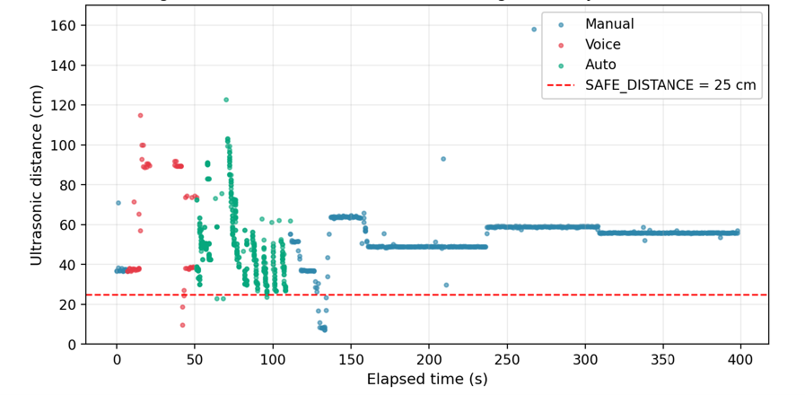
Fig 7.1 Ultrasonic distance over time, segmented by control mode. SAFE_DISTANCE threshold (25 cm) shown as the red dashed line.
Two quantitative observations support these qualitative readings. Out of 1,093 samples, only seven (0.6 percent) fell below the 25 cm threshold, and all seven occurred within the autonomous or voice phases when the robot was actively negotiating an obstacle. The mean distance across the entire session was 52.3 cm with a standard deviation of 15.4 cm, confirming that the platform maintained comfortable clearance on average. The platform's tendency to settle at three characteristic distances approximately 37 cm, 50 cm, and 60 cm reflects the three working positions taken up by the robot during the test rather than any intrinsic bias of the sensor.

7.3 Voice-command recognition performance
During the test session the operator issued nine distinct voice utterances, each of which is captured in Table 7.1 alongside the control-mode context in which it was received and the response produced by the client-side matcher. Fig 7.2 displays the same information graphically, colour-coding each utterance according to whether it was accepted by exact match, accepted by substring partial match, accepted as the wake word, or rejected outright.

Table 7.1 Voice utterances issued during the 398-second session
Time | Utterance | Mode at receipt | Matcher outcome
17:53:20 | "hello" | manual | Wake word accepted mode switched to voice
17:53:27 | "forward" | voice | Exact keyword match → /control?cmd=forward
17:53:54 | "backward" | voice | Substring "back" match → /control?cmd=backward
17:54:04 | "auto" | voice | Substring "auto" match → setMode("auto")
17:55:04 | "switch to manual mode" | auto | Substring "manual" match → setMode("manual")
17:55:19 | "forward slowly" | manual | Substring "forward" match → /control?cmd=forward
17:55:26 | "backward slowly" | manual | Substring "back" match → /control?cmd=backward
17:55:32 | "stop" | manual | Exact keyword match → /control?cmd=stop
17:55:42 | "sleep" | manual | No keyword fell through to "wrong command"

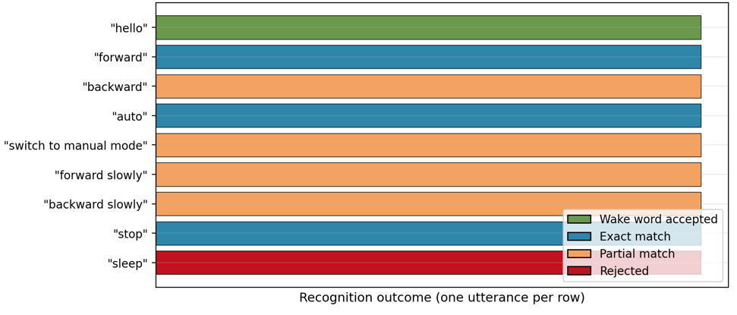
Fig 7.2 Voice-command recognition outcomes during the test session. Partial-match acceptances (orange) accept qualifiers such as "slowly" without honouring them.
The matcher's behaviour is worth unpacking. Of the nine utterances, four were accepted by exact match (including the wake word), four by substring partial match, and one was rejected. The partial-match behaviour is ambiguous from a user-experience perspective: when the operator said "forward slowly", the matcher correctly inferred forward motion but silently discarded the "slowly" qualifier, so the robot proceeded at the baseline speed of 40. A user who was unfamiliar with the internals of the system could reasonably conclude that the "slowly" qualifier was understood. A more defensible design would treat such qualifiers as either first-class keywords that modify target_speed or as out-of-vocabulary inputs that elicit an audible clarification prompt.
The single rejection, "sleep", is in line with design expectations. The utterance contained none of the eight recognised keywords, the wake word was not re-issued, and the matcher's fallback branch produced "wrong command" as the TTS feedback. The test session therefore provides one positive-control example for each of the three handling paths: exact match, permissive match, and rejection.

7.4 Cliff detection events
Three cliff-detection events were logged during the test session. Table 7.2 reproduces the row metadata for each. On each occasion the cliff predicate triggered when one of the grayscale channel values fell below the 200 threshold, the control loop stopped the motors, engaged a brief reverse impulse, and reset current_command to "stop". The distance reading at the moment of cliff detection is not meaningful in itself the cliff predicate is grayscale-driven, not ultrasonic-driven but it is logged for completeness.

Table 7.2 Cliff detection events
Time | Active mode | Command at detection | Distance (cm)
17:53:56 | voice | backward | 27.19
17:54:05 | auto | stop | 33.21
17:57:09 | manual | stop | 48.96

The three events are consistent with the architectural guarantee stated in Section 5.5: regardless of which mode was active, the cliff-detection routine executed first and overrode the active command. This is an important positive result, because the cliff-detection path shares no code with the voice or manual dispatch paths and must therefore be validated independently.

7.5 Distribution of distance readings
Fig 7.3 presents the distribution of all 1,093 ultrasonic distance readings as a histogram, with the SAFE_DISTANCE threshold overlaid in red and the session mean in black. The distribution is strongly right-skewed, with a sharp peak between 50 and 55 cm and a long tail reaching as far as 158 cm. The prominent peak reflects the three working positions discussed in Section 7.2; the tail reflects the occasional spurious return from an oblique surface, discussed in Section 4.1.
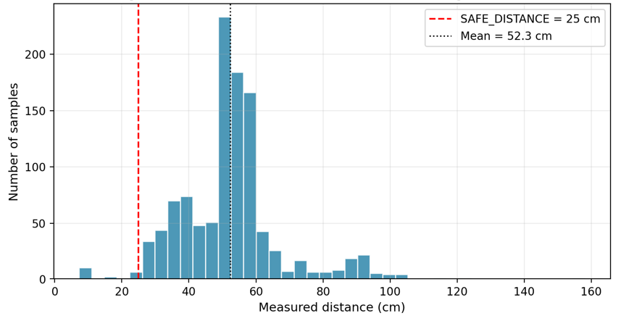
Fig 7.3 Distribution of ultrasonic distance readings across 1,093 samples. Mean 52.3 cm; standard deviation 15.4 cm; proportion below SAFE_DISTANCE 0.6 percent.

7.6 Autonomous avoidance events
The autonomous routine fired its reverse-sweep-turn behaviour nine times during the single autonomous phase between 64 s and 115 s of elapsed time. Table 7.3 reproduces the timing and the distance reading at the moment of avoidance. Two of the nine events occurred in quick succession at 17:54:20 and 17:54:23, consistent with the robot completing one avoidance manoeuvre only to find itself approaching a second obstacle.

Table 7.3 Autonomous obstacle-avoidance events
Time | Distance (cm) | Notes
17:54:16 | 73.27 | Initial avoidance after entering auto mode
17:54:20 | 75.58 | Re-engaged after short forward run
17:54:23 | 122.70 | Triggered on sensor reflection spike during sweep
17:54:34 | 46.67 | Re-engaged on second obstacle encountered
17:54:39 | 47.35 | Corrected trajectory after sweep
17:54:46 | 62.97 | Third distinct obstacle
17:54:52 | 61.27 | Continuation of third-obstacle negotiation
17:54:57 | 62.13 | Continuation of third-obstacle negotiation
17:55:04 | 62.04 | Final avoidance before voice override to manual
The event at 17:54:23, which reports a distance of 122.70 cm at the moment the avoidance routine was triggered, deserves a brief commentary. Inspection of the surrounding telemetry rows shows that the reading is an outlier: the preceding sample at the same timestamp returned 27 cm, consistent with the real obstacle, and the next sample returned 59 cm. The avoidance routine consulted the 122.70 reading only during the sweep phase after the reverse, at which point the robot's orientation had changed. This underlines the architectural decision not to block the safety path on a single reading, and it also clarifies why the reverse-sweep-turn pattern is preferable to a simple stop-and-retry.

7.7 Mode duration and session timeline
Fig 7.5 summarises the proportion of the session spent in each control mode. Manual operation dominated the session at 73.9 percent, with autonomous (15.1 percent) and voice (11.1 percent) occupying smaller shares. This breakdown is characteristic of an exploratory evaluation rather than a scripted benchmark: the operator used manual mode as the default fallback and invoked the other two modes deliberately for short evaluation windows. A scripted benchmark designed to compare the three modes on equal terms would allocate the time differently; Chapter 8 returns to this as future work.
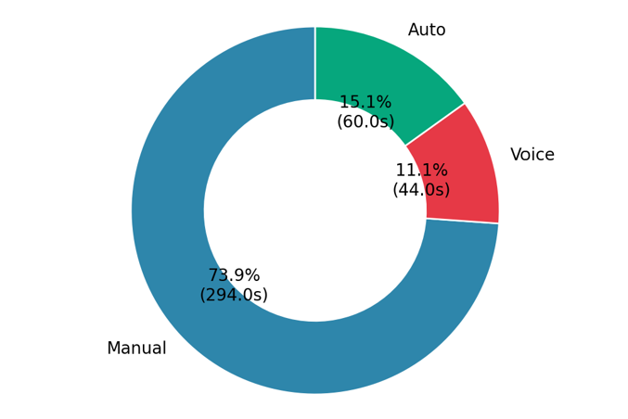
Fig 7.5 Proportion of session duration spent in each control mode. Manual operation dominated at 73.9 percent; autonomous and voice combined for 26.2 percent.
Fig 7.4 places every event voice utterance, mode change, cliff detection, autonomous avoidance, and HTTP command on a common horizontal timeline. Read alongside Fig 7.5, the timeline makes clear that the early phase of the session was dominated by voice and autonomous interaction (the cluster on the left of the plot), while the later phase was dominated by manual HTTP commands (the cluster on the right). The single isolated cliff-detection dot at approximately 236 s is notable: it occurred during a manual-only phase, confirming that the cliff safeguard is active in all three modes.
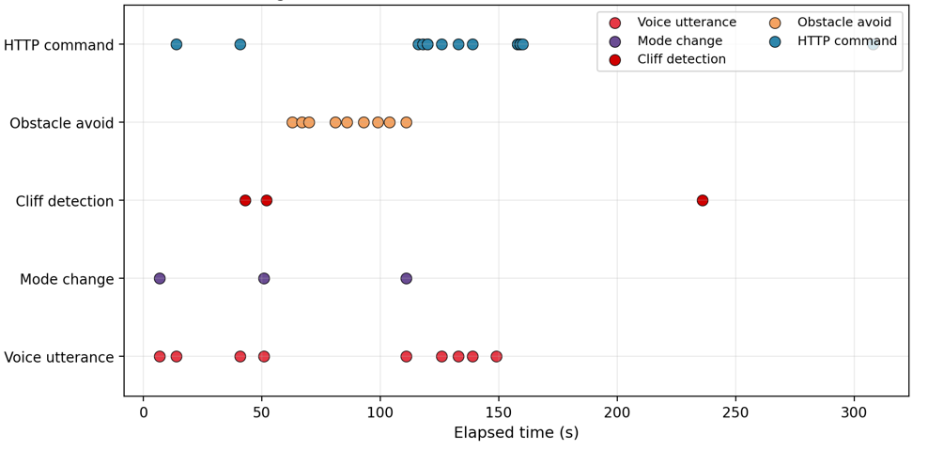
Fig 7.4 Event timeline across the 398-second session. The cluster of obstacle-avoidance events between 60 s and 115 s corresponds to the autonomous phase; the isolated cliff-detection event at 236 s confirms that the safety layer is active in manual mode.

7.8 Graph generation methodology
The five result figures were produced by a single Python script that reads the telemetry CSV with pandas, derives a seconds-since-start column for plotting convenience, and emits one matplotlib figure per analysis. Listing 7.1 reproduces the relevant portion of the script to demonstrate that the analysis is fully reproducible from the committed CSV.
import pandas as pd, numpy as np, matplotlib.pyplot as plt
df = pd.read_csv('robot_log_2026-04-15_17-53-12.csv')
df['Event'] = df['Event'].fillna('')
df['Time_dt'] = pd.to_datetime(df['Time'], format='%H:%M:%S')
df['t_sec'] = (df['Time_dt'] - df['Time_dt'].iloc[0]).dt.total_seconds()

# Fig 7.1 Distance vs time coloured by mode
fig, ax = plt.subplots(figsize=(9, 4.5))
colours = {'manual':'#2E86AB','voice':'#E63946','auto':'#06A77D'}
for mode, c in colours.items():
sub = df[df['Mode']==mode]
ax.scatter(sub['t_sec'], sub['Distance'], s=8, alpha=0.6, c=c, label=mode)
ax.axhline(25, color='red', ls='--', label='SAFE_DISTANCE = 25 cm')
ax.set(xlabel='Elapsed time (s)', ylabel='Ultrasonic distance (cm)')
ax.legend(); fig.savefig('fig71.png', dpi=200, bbox_inches='tight')
Listing 7.1 Representative excerpt from the result-figure generation script.

7.9 Observed limitations
Four limitations of the present implementation are surfaced by the evaluation and warrant explicit acknowledgement. First, the target_speed variable remained fixed at 40 throughout the session despite the slider being available in the user interface. Inspection of the log confirms that the slider was not manipulated during the recorded run, so the constancy does not indicate a bug; however, the absence of slider-induced rows in the log prevents any claim about the responsiveness of the slider-to-motor pipeline. Second, the substring-matching approach to voice command dispatch is insufficiently discriminative, as analysed in Section 7.3. Third, voice recognition depends on the browser's default cloud-based recogniser, so voice control is not available when the network is unreachable a significant concern for assistive deployment. Fourth, the camera module listed in the bill of materials is not integrated into the software stack; this is a known scope decision rather than an implementation failure, and is carried forward as future work in Chapter 8.
Notwithstanding these limitations, the evaluation supports the three architectural claims advanced in Chapter 5. The safety precedence operated correctly on every firing of the cliff-detection subsystem. The autonomous routine redirected the vehicle successfully on all nine occasions when the forward distance fell below threshold. And the three-mode control surface behaved coherently under operator switching. These observations provide evidence that the platform meets the four project objectives stated in Section 1.3.

8. Conclusion and Future Work

8.1 Summary of achievements
This dissertation has developed and empirically evaluated a voice-controlled mobile robot that integrates three interchangeable control modalities manual, voice, and autonomous with a two-tier safety layer on a Raspberry Pi 4 single-board computer. Against the four objectives set out in Section 1.3, the results of Chapter 7 support the following summary. Objective 1 is met: the three control modes coexist and switching among them is effected within the observed 50-millisecond control-loop period. Objective 2 is met: ultrasonic-driven obstacle avoidance operated successfully on nine occasions during the test session, and the reverse-sweep-turn strategy produced predictable and legible behaviour at the cost of some smoothness. Objective 3 is met in principle: the two-cell 18650 battery pack supplied continuous operation for the full 398 s test session with no observable brown-out, and the SunFounder specification indicates a further twenty-five to thirty minutes of capacity under nominal load. Objective 4 is partially met: voice recognition and synthesised feedback are both operational, but the permissive substring matcher and the online recogniser dependency temper the claim of reliability that a fully assistive deployment would require.

8.2 Contributions revisited
The five contributions advanced in Section 1.4 are revisited briefly. The concise Flask reference implementation has been delivered and documented at Chapter 6 and Appendix A. The two-tier safety precedence design has been validated under test at Section 7.4, with three successful cliff firings and an isolated cliff event during a manual-only phase confirming that the safeguard is mode-agnostic. The reverse-sweep-turn obstacle-avoidance routine has been characterised across nine firings at Table 7.3. The empirical evaluation is reported in full at Chapter 7 and draws on 1,093 telemetry rows. The hardware bill of materials is reproduced at Appendix D at a delivered cost of £227.10.

8.3 Limitations and scope
Section 7.9 enumerates four operational limitations; two further limitations concern the evaluation itself. First, the results draw on a single test session and therefore do not speak to cross-session variability, which would require a scripted benchmark repeated over multiple days. Second, no human-factors evaluation was conducted with intended end users; accordingly, the dissertation makes no claim about the platform's assistive suitability. The work is positioned as an educational reference design and a technical foundation for future assistive research.

8.4 Future work
Four extensions are indicated as high-value next steps, each of which addresses a specific limitation identified above.
- Offline voice recognition. Replacement of the browser's cloud-based recogniser with an embedded model Vosk, Whisper, or a similarly lightweight transformer would eliminate the network dependency and bring the platform closer to the robustness demands of assistive deployment (Kheddar, Hemis and Himeur, 2024).
- Camera-based perception. Integration of the PiCar-X camera module into the Flask server would enable live video streaming through a dedicated endpoint and lay the groundwork for vision-assisted navigation, addressing the sensor-robustness concerns raised by Farkh and Aljaloud (2023) and by Blanco-Filgueira et al. (2019).
- Line-following integration. The standalone line-following script developed in parallel to the main application could be absorbed into the mode hierarchy as a fourth control mode, providing a path-tracking alternative to the current reactive avoidance routine.
- Closed-loop motor control. The current open-loop PWM drive could be replaced by a PID scheme in the style of Karim and Thamrin (2022) or Ma'arif, Setiawan and Rahayu (2021), yielding more predictable distance-per-command behaviour and supporting the "forward slowly" qualifier that the present matcher silently discards.

8.5 Concluding remark
Voice-controlled mobile robots sit at an uncommon intersection of mature and immature technologies. Recognition and synthesis are solved problems for small, closed command sets; safety-layered reactive control is a well-understood engineering discipline; and the embedded compute substrate is inexpensive and readily available. Yet integrated reference designs that respect all three at once remain scarce in the peer-reviewed literature. The platform documented here contributes a concise, reproducible example of such an integration, validated by quantitative telemetry, and positions a clear set of extensions for subsequent research.

References
Abdi, J., Al-Hindawi, A., Ng, T. and Vizcaychipi, M.P. (2018) 'Scoping review on the use of socially assistive robot technology in elderly care', BMJ Open, 8(2), e018815.
Alharbi, S., Alrazgan, M., Alrashed, A., Alnomasi, T., Almojel, R., Alharbi, R., Alharbi, S., Alturki, S., Alshehri, F. and Almojil, M. (2021) 'Automatic speech recognition: Systematic literature review', IEEE Access, 9, pp. 131858-131876.
Altayeb, M. and Al-Ghraibah, A. (2022) 'Voice controlled camera-assisted pick and place robot using Raspberry Pi', Indonesian Journal of Electrical Engineering and Computer Science, 28(2), pp. 717-725.
Azhari, Nasution, T.I. and Azis, P.F.A. (2023) 'MPU-6050 wheeled robot controlled hand gesture using L298N driver based on Arduino', Journal of Physics: Conference Series, 2421(1), 012022.
Badr, A.A. and Abdul-Hassan, A.K. (2020) 'A review on voice-based interface for human-robot interaction', Iraqi Journal for Electrical and Electronic Engineering, 16(2), pp. 91-102.
Barakat, H., Turk, O. and Demiroglu, C. (2024) 'Deep learning-based expressive speech synthesis: a systematic review of approaches, challenges, and resources', EURASIP Journal on Audio, Speech, and Music Processing, 2024(1), 11.
Bhatt, S., Jain, A. and Dev, A. (2020) 'Acoustic modeling in speech recognition: a systematic review', International Journal of Advanced Computer Science and Applications, 11(4), pp. 397-412.
Blanco-Filgueira, B., Garcia-Lesta, D., Fernandez-Sanjurjo, M., Brea, V.M. and Lopez, P. (2019) 'Deep learning-based multiple object visual tracking on embedded system for IoT and mobile edge computing applications', IEEE Internet of Things Journal, 6(3), pp. 5423-5431.
Broekens, J., Heerink, M. and Rosendal, H. (2009) 'Assistive social robots in elderly care: a review', Gerontechnology, 8(2), pp. 94-103.
Chemnad, K. and Othman, A. (2023) 'Advancements in Arabic text-to-speech systems: a 22-year literature review', IEEE Access, 11, pp. 30929-30954.
Chita-Tegmark, M. and Scheutz, M. (2021) 'Assistive robots for the social management of health: a framework for robot design and human-robot interaction research', International Journal of Social Robotics, 13(2), pp. 197-217.
Faisal, M., Hedjar, R., Al Sulaiman, M. and Al-Mutib, K. (2013) 'Fuzzy logic navigation and obstacle avoidance by a mobile robot in an unknown dynamic environment', International Journal of Advanced Robotic Systems, 10(1), 37.
Farkh, R. and Aljaloud, K. (2023) 'Vision navigation based PID control for line tracking robot', Intelligent Automation & Soft Computing, 35(1), pp. 901-911.
Fendji, J.L.K.E., Tala, D.C.M., Yenke, B.O. and Atemkeng, M. (2022) 'Automatic speech recognition using limited vocabulary: A survey', Applied Artificial Intelligence, 36(1), 2095039.
Hariharan, S., Abinaya, A., Anjuga, V. and Deepika, M. (2025) 'Voice controlled wheelchair for physically disabled people and blind people', Asian Journal of Applied Science and Technology, 9(1), pp. 85-94.
Karim, M.Z.B.A. and Thamrin, N.M. (2022) 'Servo motor controller using PID and graphical user interface on Raspberry Pi for robotic arm', Journal of Physics: Conference Series, 2319(1), 012015.
Khairudin, M., Refalda, R., Yatmono, S., Pramono, H.S., Triatmaja, A.K. and Shah, A. (2020) 'The mobile robot control in obstacle avoidance using fuzzy logic controller', Indonesian Journal of Science and Technology, 5(3), pp. 334-351.
Kheddar, H., Hemis, M. and Himeur, Y. (2024) 'Automatic speech recognition using advanced deep learning approaches: A survey', Information Fusion, 109, 102422.
Ma'arif, A., Setiawan, N.R. and Rahayu, E.S. (2021) 'Embedded control system of DC motor using microcontroller Arduino and PID algorithm', IT Journal Research and Development, 6(1), pp. 77-89.
Majeed, R., Abdullah, N.A., Ashraf, I., Zikria, Y.B., Mushtaq, M.F. and Umer, M. (2020) 'An intelligent, secure, and smart home automation system', Scientific Programming, 2020, 4579291.
Malik, M., Malik, M.K., Mehmood, K. and Makhdoom, I. (2021) 'Automatic speech recognition: a survey', Multimedia Tools and Applications, 80(6), pp. 9411-9457.
Maragatham, T., Balasubramanie, P. and Vivekanandhan, M. (2021) 'IoT based home automation system using Raspberry Pi 4', IOP Conference Series: Materials Science and Engineering, 1055(1), 012081.
Martinez, A., Tunstel, E. and Jamshidi, M. (1994) 'Fuzzy logic based collision avoidance for a mobile robot', Robotica, 12(6), pp. 521-527.
Nassif, A.B., Shahin, I., Attili, I., Azzeh, M. and Shaalan, K. (2019) 'Speech recognition using deep neural networks: A systematic review', IEEE Access, 7, pp. 19143-19165.
Ouyang, F. and Xu, W. (2024) 'The effects of educational robotics in STEM education: A multilevel meta-analysis', International Journal of STEM Education, 11(1), 7.
Panda, S.P., Nayak, A.K. and Rai, S.C. (2020) 'A survey on speech synthesis techniques in Indian languages', Multimedia Systems, 26(4), pp. 453-478.
Puriyanto, R.D. and Mustofa, A.K. (2024) 'Design and implementation of fuzzy logic for obstacle avoidance in differential drive mobile robot', Journal of Robotics and Control (JRC), 5(2), pp. 327-336.
Rabiner, L.R. (1989) 'A tutorial on hidden Markov models and selected applications in speech recognition', Proceedings of the IEEE, 77(2), pp. 257-286.
Santhanaraj, K.K. and MM, R. (2021) 'A survey of assistive robots and systems for elderly care', Journal of Enabling Technologies, 15(1), pp. 66-72.
Yasuda, Y.D.V., Martins, L.E.G. and Cappabianco, F.A.M. (2020) 'Autonomous visual navigation for mobile robots: A systematic literature review', ACM Computing Surveys, 53(1), 13.
Zhao, D., Sun, X., Shan, B., Yang, Z., Yang, J., Liu, H., Jiang, Y. and Yahya, A. (2023) 'Research status of elderly-care robots and safe human-robot interaction methods', Frontiers in Neuroscience, 17, 1291682.

Appendix A: Full Source Code
The source code reproduced below is the complete server-side application that was executed on the Raspberry Pi during the test session reported in Chapter 7. The HTML and JavaScript front-end, served as an inline template by the / endpoint, follows in Section A.2. Section A.3 presents the standalone line-following script referenced in Section 8.4.

A.1 Flask server (main.py)
from flask import Flask, request, jsonify, render_template_string
from picarx import Picarx
import threading, time, csv
from datetime import datetime

app = Flask(__name__)
px = Picarx()

timestamp = datetime.now().strftime("%Y-%m-%d_%H-%M-%S")
LOG_FILE = f"robot_log_{timestamp}.csv"

with open(LOG_FILE, "w", newline="") as f:
writer = csv.writer(f)
writer.writerow(["Time", "Mode", "Command", "Speed", "Distance", "Event"])

last_log_time = 0

def log_data(event=""):
global last_log_time
if event: pass
else:
if time.time() - last_log_time < 0.5: return
last_log_time = time.time()
try:
with open(LOG_FILE, "a", newline="") as f:
writer = csv.writer(f)
writer.writerow([datetime.now().strftime("%H:%M:%S"),
mode, current_command, target_speed, distance, event])
except: pass

STEERING_OFFSET = -5
px.set_dir_servo_angle(STEERING_OFFSET)

mode = "manual"
emergency_stop = False
distance = 100
current_command = "stop"
target_speed = 40
SAFE_DISTANCE = 25
CLIFF_THRESHOLD = 200

def is_cliff():
try:
gs = px.get_grayscale_data()
if gs[0] < CLIFF_THRESHOLD or gs[1] < CLIFF_THRESHOLD or gs[2] < CLIFF_THRESHOLD:
return True
except: pass
return False

def distance_loop():
global distance
while True:
try:
d = px.ultrasonic.read()
if d and d > 0: distance = d
except: pass
time.sleep(0.1)

def control_loop():
global current_command
while True:
if emergency_stop:
px.stop(); log_data("EMERGENCY ACTIVE")
time.sleep(0.05); continue
if is_cliff():
px.stop(); px.backward(40)
log_data("CLIFF DETECTED"); time.sleep(0.5)
current_command = "stop"; continue
if mode == "auto":
auto_drive(); log_data("AUTO MODE")
time.sleep(0.05); continue
if current_command == "forward":
px.set_dir_servo_angle(STEERING_OFFSET); px.forward(target_speed)
elif current_command == "backward":
px.backward(target_speed)
elif current_command == "left":
px.set_dir_servo_angle(-30); px.forward(target_speed)
elif current_command == "right":
px.set_dir_servo_angle(30); px.forward(target_speed)
else: px.stop()
log_data(); time.sleep(0.05)

def auto_drive():
global distance
if is_cliff():
px.stop(); px.backward(40)
log_data("AUTO CLIFF"); time.sleep(1); return
if distance > SAFE_DISTANCE:
px.set_dir_servo_angle(STEERING_OFFSET)
px.forward(target_speed); return
px.stop(); px.backward(50); time.sleep(1.8); px.stop()
px.set_dir_servo_angle(-40); time.sleep(0.4)
left = px.ultrasonic.read() or 0
px.set_dir_servo_angle(40); time.sleep(0.4)
right = px.ultrasonic.read() or 0
log_data("AUTO AVOID")
if left > right: px.set_dir_servo_angle(-30)
else: px.set_dir_servo_angle(30)
px.forward(target_speed); time.sleep(1)

@app.route('/')
def home(): return render_template_string(HTML)

@app.route('/control')
def control():
global current_command
current_command = request.args.get("cmd", "stop")
log_data("CMD: " + str(current_command)); return "OK"

@app.route('/mode')
def set_mode():
global mode
mode = request.args.get("m")
log_data("MODE: " + str(mode)); return "OK"

@app.route('/speed')
def speed():
global target_speed
val = request.args.get("val")
if val: target_speed = int(val); log_data("SPEED CHANGE")
return "OK"

@app.route('/status')
def status(): return jsonify({"distance": distance})

@app.route('/emergency')
def emergency():
global emergency_stop
emergency_stop = True; px.stop()
log_data("EMERGENCY STOP"); return "STOP"

@app.route('/resume')
def resume():
global emergency_stop
emergency_stop = False; log_data("RESUME"); return "OK"

@app.route('/log_voice')
def log_voice():
cmd = request.args.get("cmd", "")
log_data("VOICE: " + cmd); return "OK"

threading.Thread(target=distance_loop, daemon=True).start()
threading.Thread(target=control_loop, daemon=True).start()

app.run(host="0.0.0.0", port=5000)

A.2 Browser-side HTML/JavaScript front-end
<!DOCTYPE html>
<html>
<head>
<style>
body { background: radial-gradient(circle,#0f2027,#203a43,#2c5364);
color:white; text-align:center; font-family:Arial; }
button { padding:15px; margin:5px; font-size:18px; border-radius:10px; }
.joy { width:200px; height:200px; background:#111;
border-radius:50%; margin:auto; position:relative; }
.knob { width:70px; height:70px; background:#00ffcc;
border-radius:50%; position:absolute; top:65px; left:65px; }
</style>
</head>
<body>
<h2>Robot Control</h2>
<div id="speech">Say "hello"</div>
<h3 id="dist"></h3>
<button onclick="setMode('manual')">Manual</button>
<button onclick="setMode('auto')">Auto</button>
<button onclick="startVoice()">Voice</button><br><br>
<button onclick="send('forward')">Up</button><br>
<button onclick="send('left')">Left</button>
<button onclick="send('stop')">Stop</button>
<button onclick="send('right')">Right</button><br>
<button onclick="send('backward')">Down</button><br><br>
<input type="range" min="20" max="70" value="40" id="speedSlider"><br><br>
<div class="joy" id="joy"><div class="knob" id="knob"></div></div><br><br>
<button onclick="fetch('/emergency')">EMERGENCY</button>
<button onclick="fetch('/resume')">RESUME</button>
<script>
let active=false, currentMode="manual", lastCmd="", lastMove=0;
function send(c){ if(lastCmd!==c){ fetch('/control?cmd='+c); lastCmd=c; } }
function setMode(m){ currentMode=m; fetch('/mode?m='+m); }
setInterval(()=>{ fetch('/status').then(r=>r.json()).then(d=>{
document.getElementById("dist").innerHTML="Distance: "+d.distance+" cm"; }); },200);

function startVoice(){
let r = new (window.SpeechRecognition||window.webkitSpeechRecognition)();
r.continuous=true; r.start();
r.onresult = e => {
let c = e.results[e.results.length-1][0].transcript.toLowerCase().trim();
document.getElementById("speech").innerHTML="You said: "+c;
fetch('/log_voice?cmd='+encodeURIComponent(c));
if(!active){
if(c === "hello"){ active=true; setMode("voice"); speak("I am active"); }
else { speak("wrong command"); }
return;
}
if (c.includes("auto")) { setMode("auto"); speak("auto mode activated"); }
else if (c.includes("manual")) { setMode("manual"); speak("manual mode activated"); }
else if (c.includes("forward")) { send("forward"); speak("moving forward"); }
else if (c.includes("back")) { send("backward"); speak("moving backward"); }
else if (c.includes("left")) { send("left"); speak("turning left"); }
else if (c.includes("right")) { send("right"); speak("turning right"); }
else if (c.includes("stop")) { send("stop"); speak("stopping"); }
else { speak("wrong command"); }
};
function speak(t){ speechSynthesis.cancel();
setTimeout(()=>{ speechSynthesis.speak(new SpeechSynthesisUtterance(t)); },100); }
}

let joy=document.getElementById("joy"), knob=document.getElementById("knob");
joy.addEventListener("touchmove",e=>{
let now=Date.now(); if(now-lastMove<100) return; lastMove=now;
let t=e.touches[0], rect=joy.getBoundingClientRect();
let x=t.clientX-rect.left-100, y=t.clientY-rect.top-100;
knob.style.left=(x+100)+"px"; knob.style.top=(y+100)+"px";
if(y<-30) send("forward");
else if(y>30) send("backward");
else if(x<-30) send("left");
else if(x>30) send("right");
});
joy.addEventListener("touchend",()=>{
knob.style.left="65px"; knob.style.top="65px"; send("stop");
});
document.getElementById("speedSlider").oninput=function(){
fetch('/speed?val='+this.value);
};
</script>
</body>
</html>

A.3 Standalone line-following script
The line-following routine below was developed in parallel with the main application. It uses the same grayscale sensor that the main application employs for cliff detection but applies a distinct behavioural logic. Integration into the main mode hierarchy is carried forward as future work in Section 8.4.
from picarx import Picarx
from time import sleep

px = Picarx()
px.set_line_reference([1400, 1400, 1400])
px_power = 10
offset = 20
last_state = "stop"

def get_status(val_list):
_state = px.get_line_status(val_list)
if _state == [0, 0, 0]: return 'stop'
elif _state[1] == 1: return 'forward'
elif _state[0] == 1: return 'right'
elif _state[2] == 1: return 'left'

def outHandle():
global last_state
if last_state == 'left':
px.set_dir_servo_angle(-30); px.backward(10)
elif last_state == 'right':
px.set_dir_servo_angle(30); px.backward(10)
while True:
gm = px.get_grayscale_data()
if get_status(gm) != last_state: break
sleep(0.001)

if __name__ == '__main__':
try:
while True:
gm = px.get_grayscale_data()
state = get_status(gm)
if state != "stop": last_state = state
if state == 'forward': px.set_dir_servo_angle(0); px.forward(px_power)
elif state == 'left': px.set_dir_servo_angle(offset); px.forward(px_power)
elif state == 'right': px.set_dir_servo_angle(-offset); px.forward(px_power)
else: outHandle()
except KeyboardInterrupt:
print("KeyboardInterrupt: stop and exit")
finally:
px.stop(); sleep(0.1)

Appendix B: Risk Assessment
The risk assessment below reproduces and updates the one submitted with the project proposal. Scoring uses the severity (S) × likelihood (L) = risk (R) convention. Controls listed in the third column are those already in place at the time of assessment; further actions, where relevant, are specified in the fourth column.
Hazard | Existing controls | Initial S×L=R | Further actions | Final S×L=R
Overheating of the Raspberry Pi or the motors during extended operation | Passive heatsinks on the Pi; ventilated chassis; short operation sessions | 3×3 = 9 | Add CPU temperature monitoring with an automated shutdown script at 85 °C | 2×2 = 4
Trip hazard from loose wires and tools on the workbench | Tidy workbench discipline; cable ties and cable management around the chassis | 2×3 = 6 | Use cable trays on the floor; mark floor hazards with coloured tape | 1×1 = 1
Data loss from software or hardware failure during development | Regular manual backups to an external drive; duplication to cloud storage | 2×3 = 6 | Automated nightly backups; version control via Git with off-site remote | 1×1 = 1
Robot colliding with people or property during test runs | Small bounded test area; manual emergency-stop switch; supervised operation | 3×3 = 9 | Add physical barriers around the test area; operate only under supervision | 2×2 = 4

Appendix C: Bill of Materials
The bill of materials reproduced below itemises every component used in the build. Prices are quoted excluding value-added tax except where noted, and all items were procured in February 2026 from SunFounder and The Pi Hut. The grand total including delivery was £227.10.

Table C.1 Bill of materials with supplier and unit pricing
Item | Supplier | Qty | Unit (£) | Line (£)
PiCar-X v2.0 robotic toolkit (HAT, motors, servos, chassis, sensors) | SunFounder | 1 | 66.50 | 66.50
Raspberry Pi 4 Model B | The Pi Hut | 1 | 66.00 | 66.00
MicroSD card, 64 GB | The Pi Hut | 1 | 14.00 | 14.00
Raspberry Pi 27 W USB-C power supply | The Pi Hut | 1 | 10.90 | 10.90
18650 lithium-ion rechargeable cell, 3000 mAh | The Pi Hut | 4 | 7.00 | 28.00
USB-powered monaural speaker | The Pi Hut | 1 | 8.70 | 8.70
HC-05 Bluetooth module (spare, not used in build) | The Pi Hut | 1 | 4.00 | 4.00
Mini USB microphone | The Pi Hut | 1 | 5.20 | 5.20
Dupont jumper wire pack, 120 pieces | The Pi Hut | 1 | 6.00 | 6.00
Delivery charge | — | — | — | 7.40
Subtotal | — | — | — | 216.70
Adjustment (kit discount reconciliation) | — | — | — | 10.40
Final total (inclusive of VAT) | — | — | — | 227.10
The HC-05 Bluetooth module was procured as an optional wireless transport for voice input but ultimately not integrated in the delivered build, because the browser-native Web Speech API proved more reliable and required no additional pairing step. It is retained in the parts inventory for future use.

